**School Uniform**

**Key Stage 1 – 3 (Reception to Year 9)**

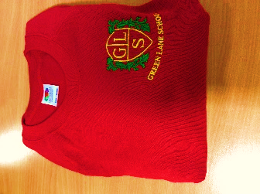

Red sweatshirt with school logo or

plain red sweatshirt / cardigan.

# White polo shirt with school logo



or plain white polo shirt.

Black or Dark Grey trousers / skirt or jog bottoms.

Red/White check dress.

Black shoes.

PE Kit – White T-shirt, Black shorts,

Black Tracksuit (in cold weather),

Pumps or Trainers.

(Any embroidered items are available from school. If you require new uniform please contact the school office. The rest of the uniform can be obtained from your local shops/high street.)

**Key Stage 4 (Years 10 and 11)**

Plain black cardigan / V neck jumper

White shirt

Red tie

Black or Dark Grey trousers / skirt

Black Shoes

(These items can be obtained from your local shops/high street)

All of the pupils are encouraged to wear school uniform.

**\*\*PLEASE ENSURE YOUR CHILD’S UNIFORM IS LABELLED\*\***