Week | Literacy  How to Catch a Star  Whatever Next  Twinkle Twinkle | Maths  Song – 5 Little Men in a Flying Saucer  Book – Ten Little Aliens | Phonics  HA – Reading Eggs/Reading books | Attention Autism | Topic | Cooking
1 | Daily shared read  Sensory story  Sensology | Counting rockets/aliens. | Recap s, a, t  Introduce: ai  Daily fine motor | Stage 2 – Meteor crashes | Light/dark sensory session  Paper mache planets | Star biscuits
2 | Daily shared read  Sensory story  Sensology | Shape rockets.  Shape aliens | Recap i, p, n  Introduce: j  Daily fine motor | Stage 2 – Glitter star prints | Foil printed moon  Marbled planets | Galaxy cupcakes
3 | Daily shared read  Sensory story  Sensology | Comparing different length rockets. | Recap ck, e, h  Introduce: oe  Daily fine motor | Stage 2 – Marble paint Northern Lights | Make space dough  Star printing | Biscuit planets
4 | Daily shared read  Sensory story  Sensology | Ordering planets by size.  Ordering aliens by size. | Recap r, m, d  Introduce: ie  Daily fine motor | Stage 2 - Moon craters | Make moon rock  Paper plat UFOs | Space rock buns
5 | Daily shared read  Sensory story  Sensology | Ordering rockets 0-10. | Recap g, o, u  Introduce: ee  Daily fine motor | Stage 2 – Clingfilm sun painting | Mentos rockets  Playdough aliens | Alien pancakes
6 | Daily shared read  Sensory story  Sensology | Make shape aliens. | Recap l, f, d  Introduce: or  Daily fine motor | Stage 2 – Alien splat | Salt dough stars  Peel and stick stars | Rocket wraps
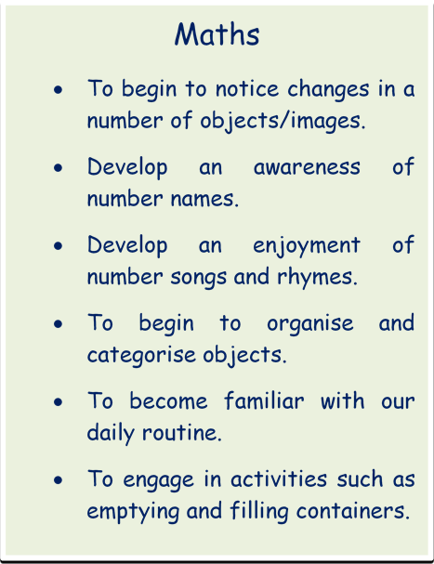
Expressive Arts/ Physical development
- To explore and experiment with a range of media through sensory exploration.
- To enjoy the experience of mark making, using a variety of media and materials.
- To take part in a variety of musical experiences.
- To take part in daily fine/gross motor activities e.g. threading/ribbon dance.
- To begin to explore tools and use these for purpose.
- To further develop our independence and self help skills.

Phonics
- To develop listening and attention skills.
- To begin to listen to familiar sounds.
- To begin to pay attention to a dominant stimulus.
- To listen to and begin to enjoy rhythm and rhyme activities.
- To blend and segment CVC words and to recognise none decodable words
- To hear the initial sound in words.
English (C&L and Lit)
- To begin to develop an interest in familiar books, stories and rhymes.
- To begin to handle books with interest.
- To begin to develop an interest in mark making, using a range of media.
- To continue to develop listening and attention skills.
- To engage with topic work linked to familiar stories.

