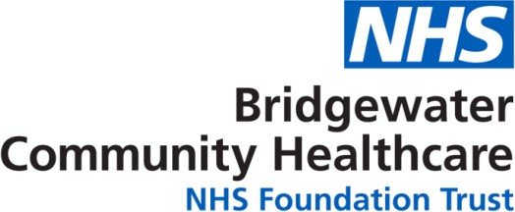

Warrington 11 - 19 Young People's Service

Text support service launches for teens

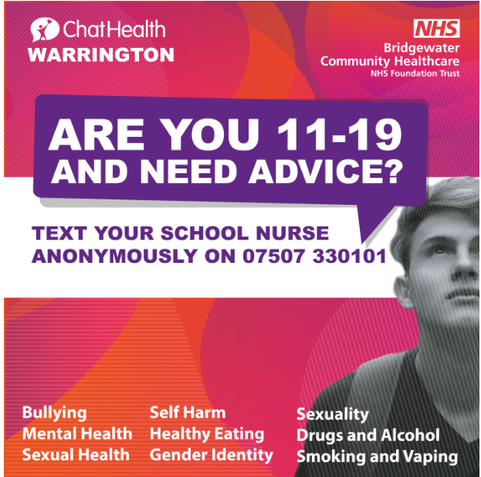
Bridgewater Community Healthcare NHS Foundation Trust is rolling out of a new secure text messaging service for young people aged 11-19 years old, enabling them to get timely and trusted health advice from a health professional (a School Nurse).

As our lives have changed over the last few months due to coronavirus, it’s more important than ever for young people to have easy access to support, particularly in the absence of face to face interaction.

The Warrington service does not aim to replace face to face contacts, rather increase choice for young people about how they access advice from a school nurse and provides a new line of communication as school nurse face to face contact in Warrington High Schools is reduced with school closures.

The ChatHealth text number will operate Monday-Friday from 9am until 5pm.

Messages will be responded to within 24 hours during this period. Outside of these hours, users will receive a ‘bounce back’ text message saying they will receive a response when the line next re-opens.

11-19 year olds can text the service on a range of issues from bullying, mental health, self harm, sexual health, drugs and alcohol, smoking and vaping, healthy eating, sexual identity, gender identity and more.

ChatHealth works by messages being sent to a dedicated phone number. These messages are then sent to a secure website and are read by a Bridgewater School Nurse who can then start a text conversation with the sender.

ChatHealth is not an emergency service, and accordingly users will be instructed to follow usual advice in seeking urgent medical attention.

The text number for 11 - 19 year olds is: 07507 330101
Or visit chathealth.nhs.uk to start a chat

