Badger class staff.

Ms K.White

Ms J.Forrest

Badger Class Summer Term 2024

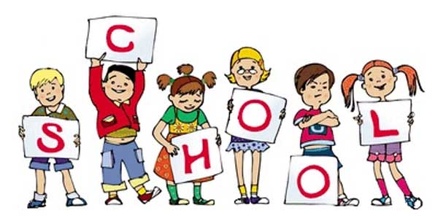

**Topics**

**Summer 1 -** Non-Chronological Reports

**Summer 2 –** Recounts

**Ongoing** - Spelling and Phonics, Guided Reading, Guided Writing, Handwriting.

Speech and language work.

**Topics**

**Summer 1 –** Measures

Capacity, mass, length, area, perimeter and temperature.

**Summer 2 –** Assessments Revisit number and statistics.

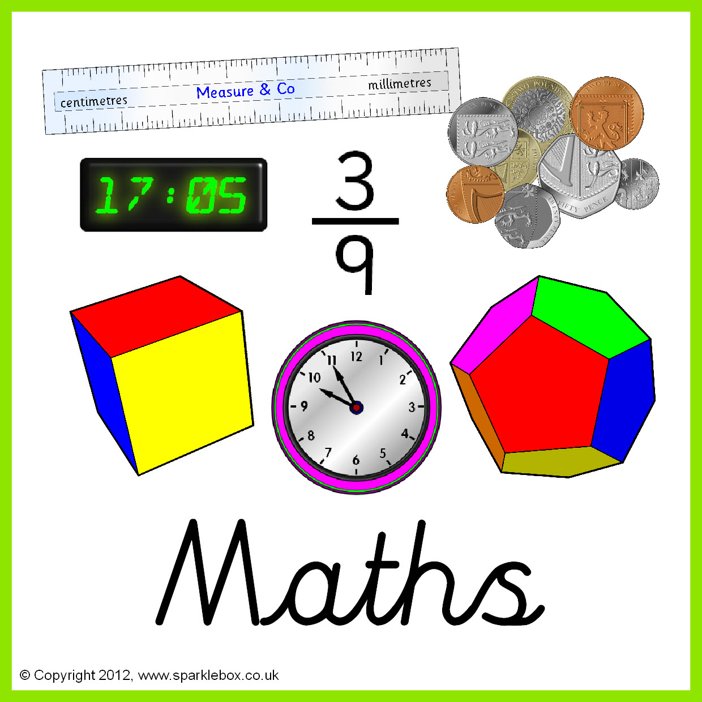



**Topics**

**Summer 1 –** Properties and changing materials.

**Summer 2 –** The human body and how it functions.

**Topics**

**Summer 1** – E-safety

**Summer 2** – Multimedia Art – Working with text.





**Topics –**

**Summer 1** – Collections

**Summer 2** – Body decoration

**Topics** -

Using maps-symbols and keys.







**Topics -**

**Summer 1** - Weather

**Summer 2** – Colours- Flags

**Topic** -

WWII (focus on the changes that happened during WWII and after)



**Topics -**

**Summer 1** – Athletics

**Summer 2** – Cricket

**Topics** - **Summer 1** – Explore the meaning behind the following festivals: Eid/al Fitr, Besak – Buddha day, Shavou and Pentacost

**Summer 2** – Explore signs and symbols for different religions.

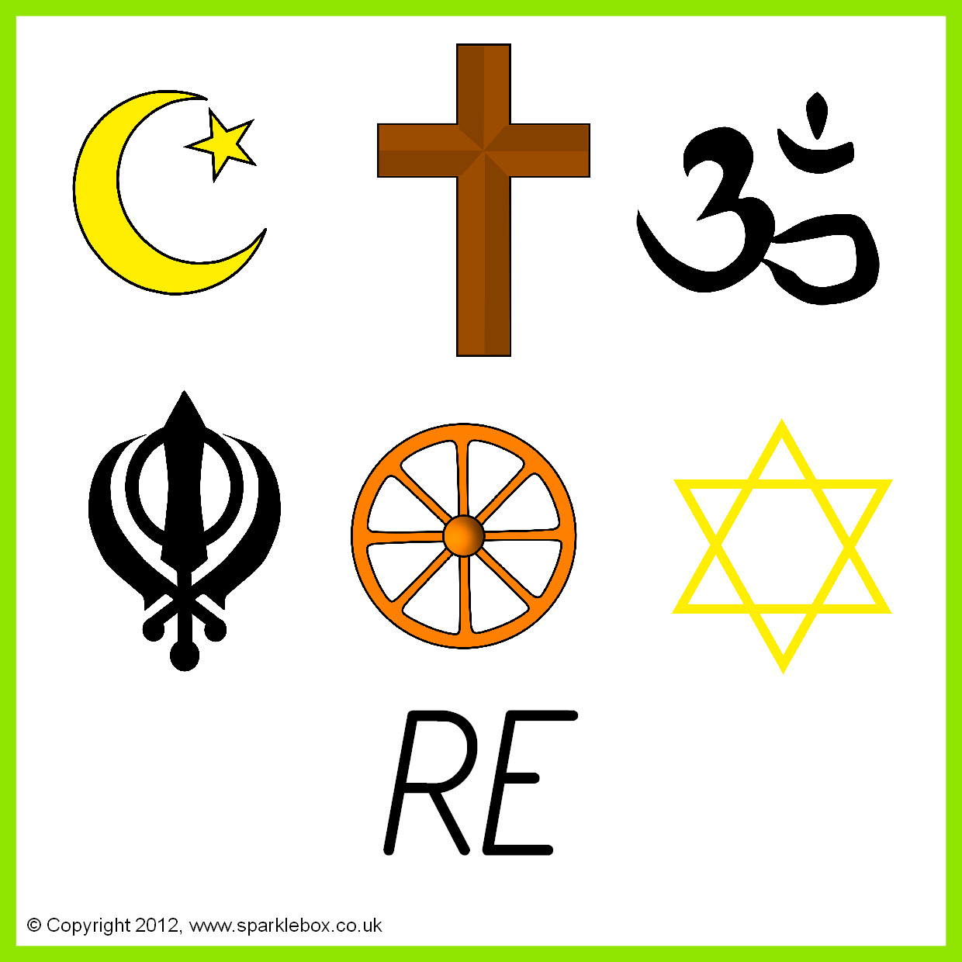



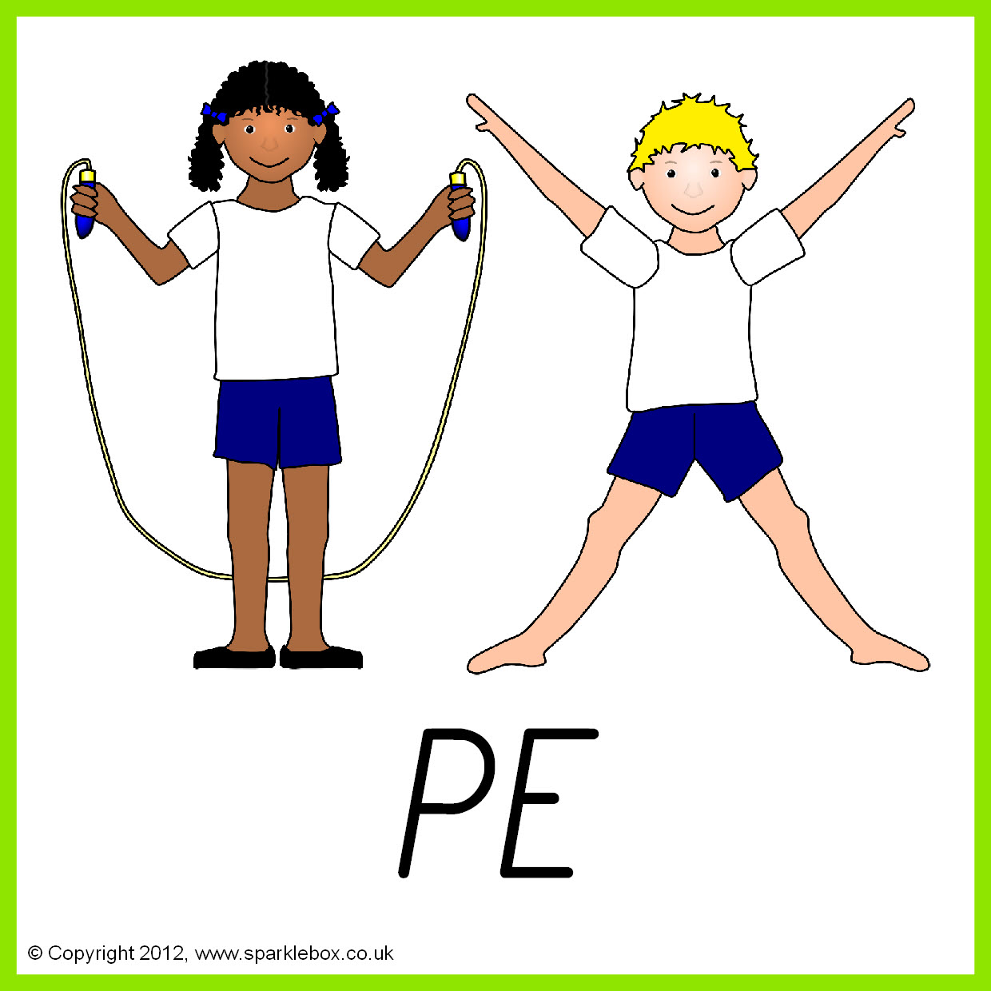

**Topics** - **Summer 1 –** Personal finance and relationships.

**Summer 2** – Enterprise

**Topics - Summer 1 –** Textiles: Designing & Making Jewellery

**Summer 2 –** Making a snack.

**Spring 2 – Basic food hygiene – Winter warmers.**

