 

Topics

Number , Money and measuring

Number recognition, counting and recognising money. Measuring in standard and non-standard forms.

Languages

Topics

*Taught through Spanish themed afternoons and attention autism*

European Languages Day – Spanish Food tasting

Spanish Christmas - Fiestas

Computing

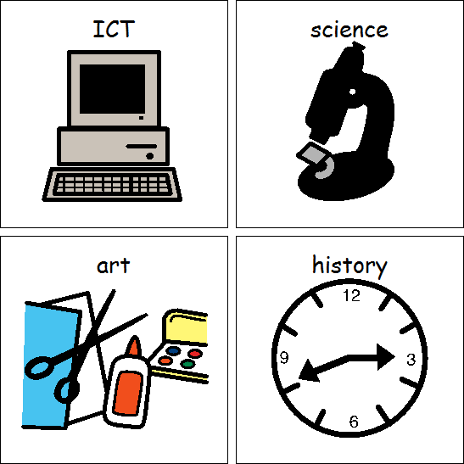

Topics

*Taught cross- curricular*

E-Safety – What do we want to see or listen too?

Multimedia: Use programmes to create a Sea Scape

Topic/SCERTS (Covers English, Science, DT, RE, Art, Geography and History)

**Under the Sea**

English: Stories around the theme e.g ‘The Rainbow Fish’, ‘Commotion in the Ocean’ and ‘The Little Mermaid’.

Science: What things are alive and what things are extinct? What are fossils and how are rocks formed?

Art: Natural Art

DT: Making Musical Instruments

FT: Fruit

RE: Jonah and the Whale, Noah’s Ark etc

Geography: Oceans

History: History of Punch and Judy

*PSHE is taught through SCERTS*

Rose Class

Autumn Overview

2022

Maths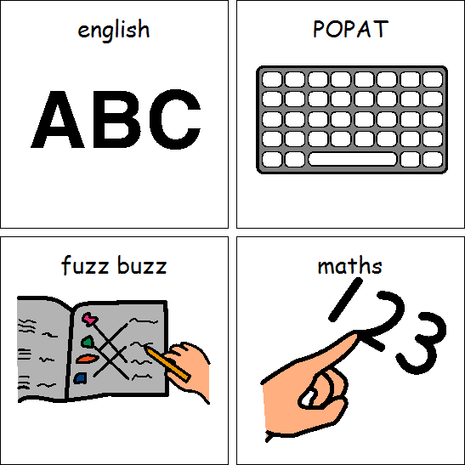

PE

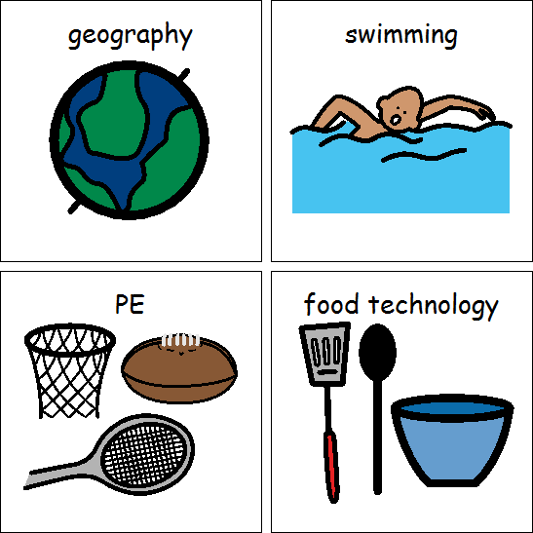

Delivered by the Wolves.

Dance

Gymnastics