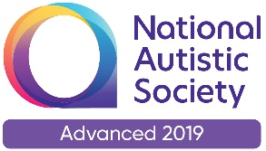 |  | Paul King  Headteacher  Joanne Mullineux  Deputy Headteacher

12th June 2020

Dear Parents / Carers

I am writing to you to explain what school will be doing over the next few weeks in terms of expanding our numbers.

You will be aware that YR, Y1, and Y6 will be returning to school next Monday (15th June.) We have contacted parents and transport (where required) and created ‘bubbles’ for the children to return to. These bubbles will be the only social group your child will have in school as we adhere to social distancing rules. Classrooms have been deep cleaned and set up for limited numbers of children. A very detailed risk assessment (see the school website) has also been written. The school and staff are well-prepared.

I know I speak for all staff when I say we are desperate to have all our children back in school. It is heart-breaking that some of our children are struggling at home. Where we have been able to, we have invited these children into school for at least a few days a week. By offering part-time timetables we are able to reach more children and offer much needed support. I know that many families have been disappointed that their child has only been offered a part-time timetable but we are trying to support all of our children and this is the fairest way we believe we can do it.

I know many parents keep in touch with each other and have networks of support via social media. Could I ask that those parents whose child can now access school, are sensitive to the feelings of other parents whose child may be part of the 75% of children who are not accessing school? Your happiness on your child’s return might add to the disappointment of other parents.

Wherever possible we will have as many children as we can accessing school in some way or another. We discuss every Thursday any child who may be struggling and how we can support them.

I really appreciate your understanding and support in these challenging times.

Yours sincerely

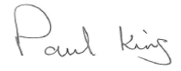

Paul King
Headteacher

