Welcome to Green Lane School

Your child will be joining Caterpillar class in September.

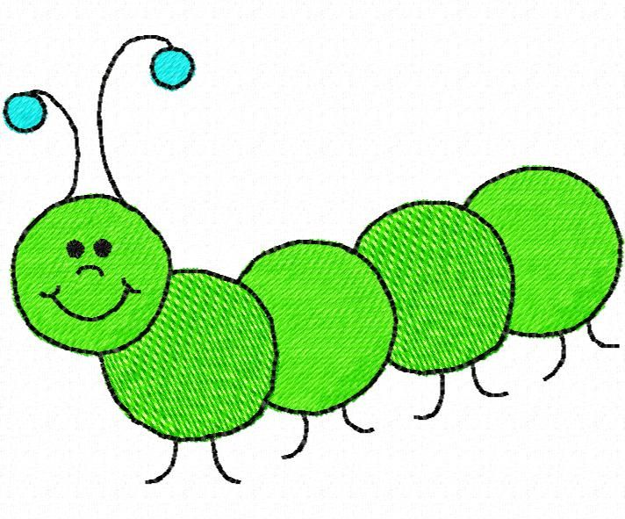

We follow the Early Years Development Matters curriculum and have a sensory approach to learning.
We provide lots of opportunities for hands on learning, encouraging children to engage in a wide variety of sensory experiences. We enjoy learning both indoors and outdoors each day.
Your child will have a home/school communication book which will be sent home at the end of each day. We also use Evidence for Learning, an online learning journal which will allow you to see photographs and videos of what your child has been doing in school. We also love to see what your child has been up to at home and encourage parents to contribute to this.

Meet the Team
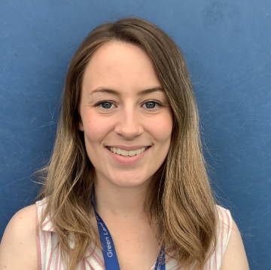

Mrs Owen-Class Teacher (EYFS Lead)

Miss Chadwick-Teaching Assistant

Mrs Laverty – Teaching Assistant

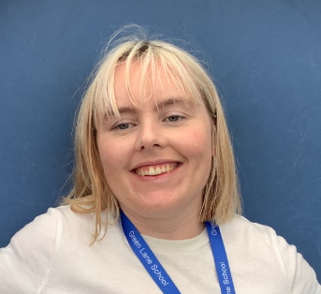

Miss Kirby – Volunteer/Midday Assistant

Our Timetable
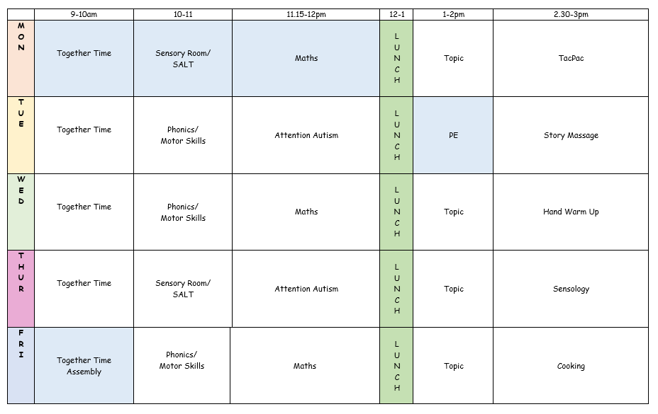

We have a morning and afternoon snack and we eat our lunch at 12. We have playtime outside each day at 11.

Children may have a school dinner or you can choose to send them with a packed lunch.

Please note we are a nut free school.

Your new classroom:
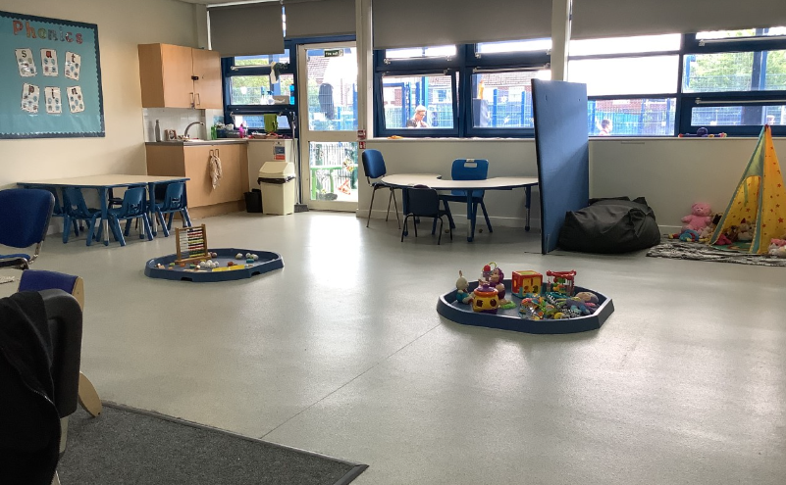
Our sensory den:
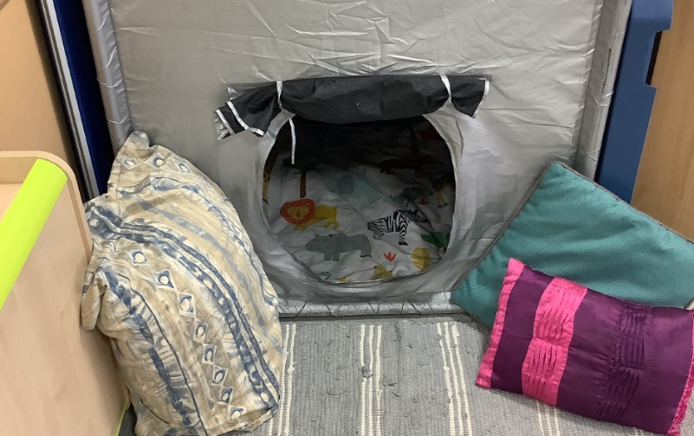

Our carpet area:
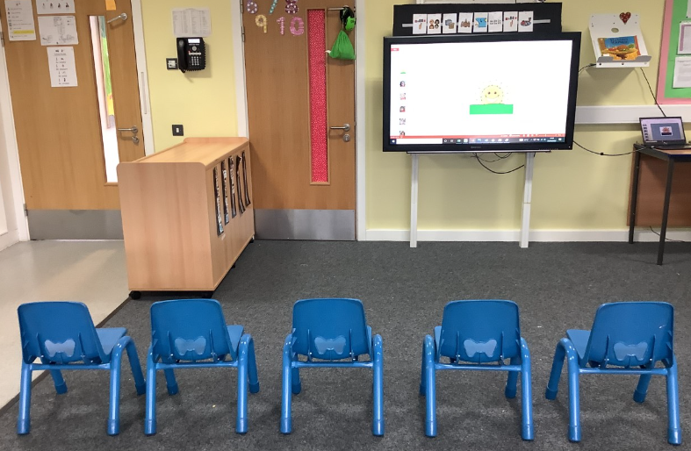

Our outdoor area:
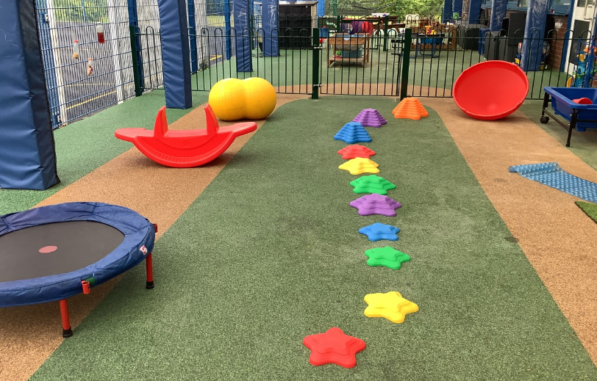

Our sensory room:
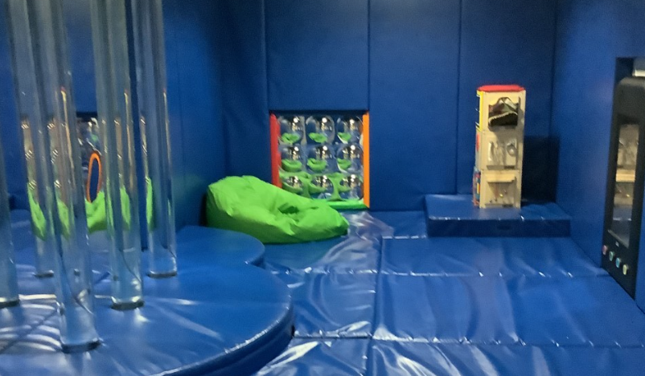

Our school field and forest area:
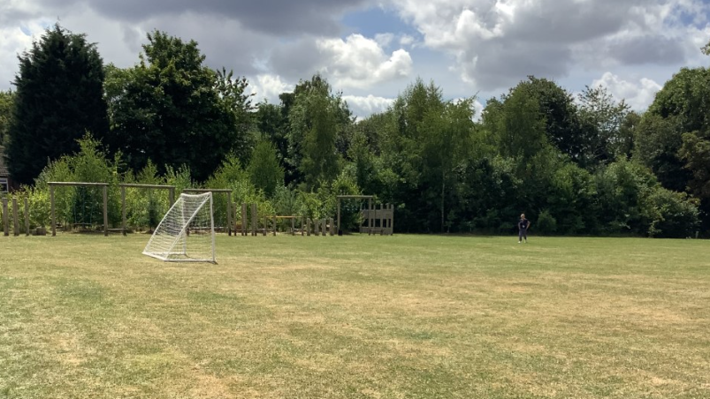

Our Topics

In the Early Years classes, we follow a topic based learning approach. This year our topics are:
Autumn A - Colours
Autumn B – Traditional Tales
Spring A – Weather and Seasons
Spring B – In the Garden
Summer A – At the Zoo
Summer B – People Who Help Us

We will also have the opportunity to do Forest School for a half term. These sessions are led by our Forest School Leaders and are supported by class staff. We are very lucky to have two wonderful Forest School areas at Green Lane School.

We look forward to working with you and your child this year!

