  Specialist School for    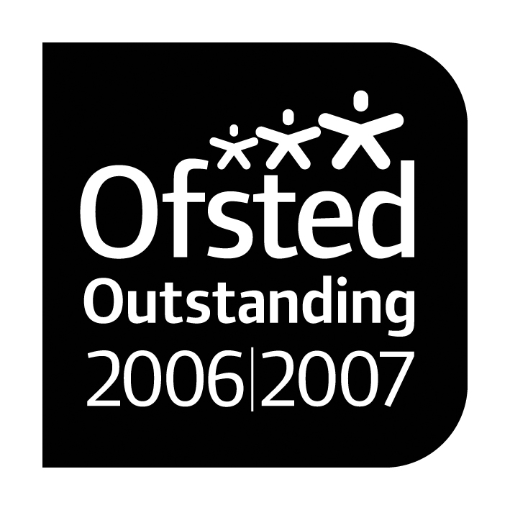      Cognition and Learning |  |   Paul King  Headteacher  Joanne Mullineux  Deputy Headteacher

26th January 2017

Dear Parents/Carers,

Over the past two weeks we have been particularly badly hit with children and staff illness. Today I have had to send another two staff and around six more children home as a result of diarrhoea or vomiting. The advice we have been given about when your child should return to school is as follows.

The child should remain off school until 48 hours have passed since the last diarrhoea or vomiting episode. It is not necessarily 48 hours after they have been sent home and in fact may be longer than 48 hours.

Some of our children have returned to school before they have fully recovered and as a consequence the vomiting and diarrhoea has spread. We would ask parents to ensure that you do not send your child back into school until 48 hours after the last episode of diarrhoea or vomiting.

Many thanks for your cooperation in this matter.

Yours sincerely

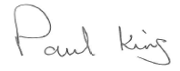
Headteacher

