Badger Class Spring Term 2022

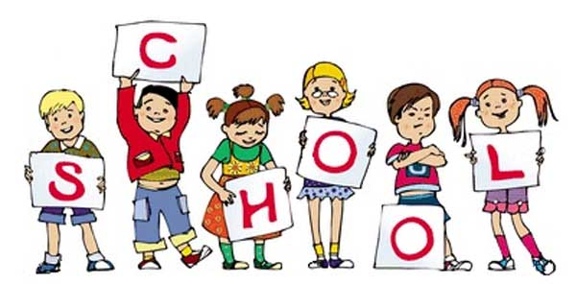

Badger class staff.

Ms K.White

Ms J.Forrest

Miss L.Dyer (1:1)

**Topics**

**Spring 1 -** Poetry- Haiku, Limericks, Shape Poems and Calligram

**Spring 2 -** Balanced Arguments

**Ongoing** - Spelling and Phonics, Guided Reading, Guided Writing, Handwriting.

Speech and language work.

**Topics**

**Spring 1 -**

Data handling and graph work.

Venn and Carroll diagrams. Tally charts and graphs.

**Spring 2 -** Multiplication and division.

Facts, written methods and problem solving.

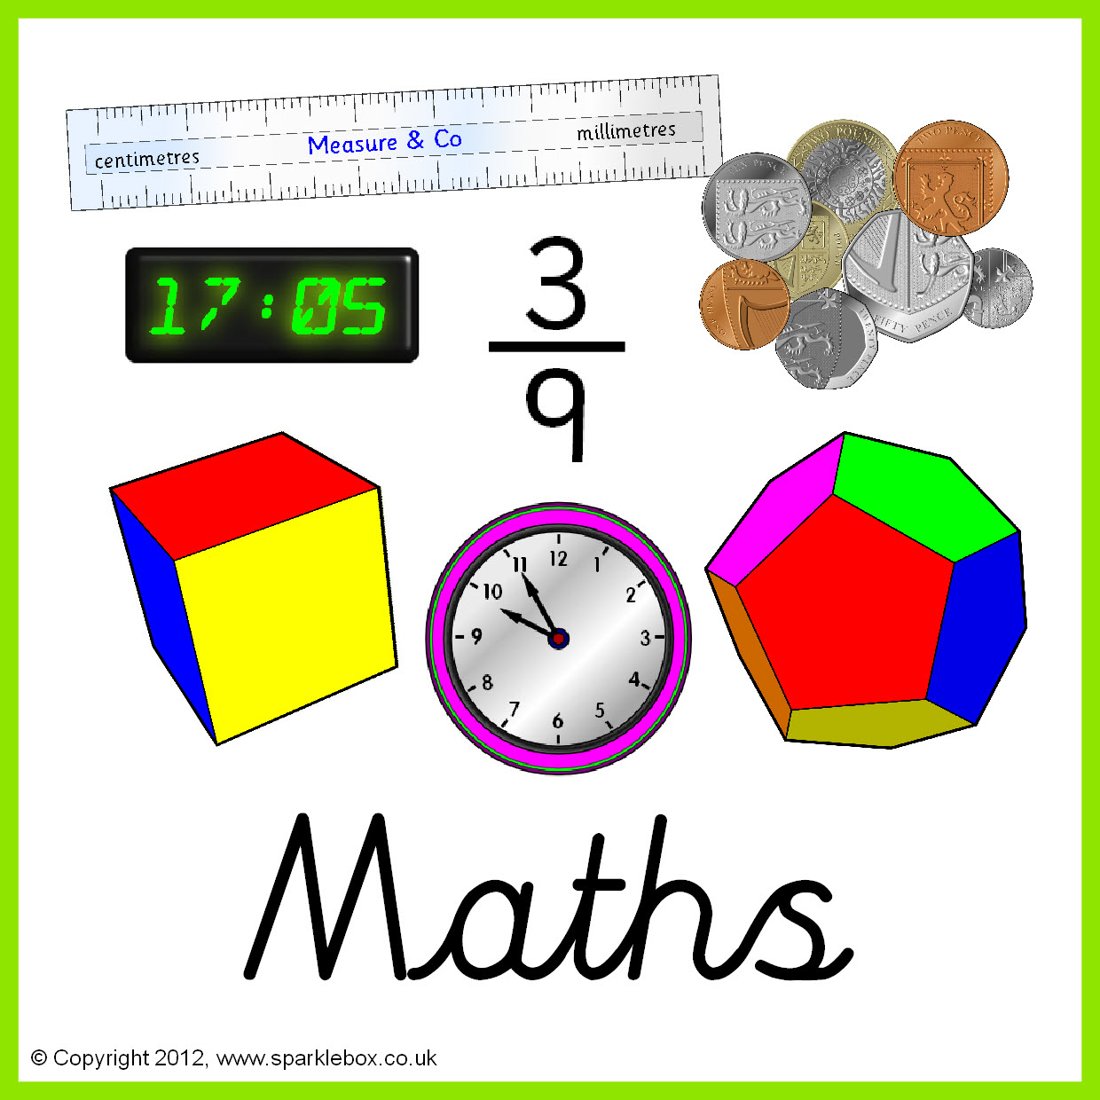

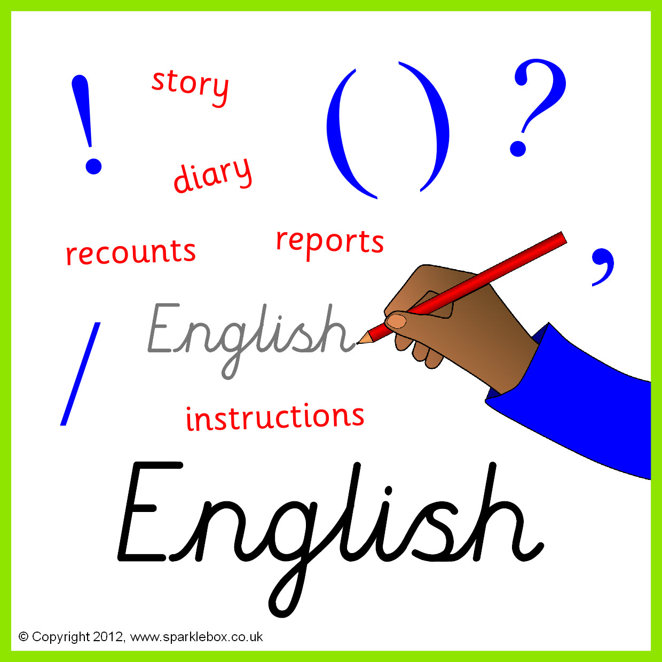

**Topics**

**Autumn 1** – Characteristics of living things.

**Autumn 2** - Waves- sound, energy and light.

Properties and changes of materials.

**Topics**

**Spring 1** – Algorithms and Programming.

**Spring 2** - Multimedia Animation.

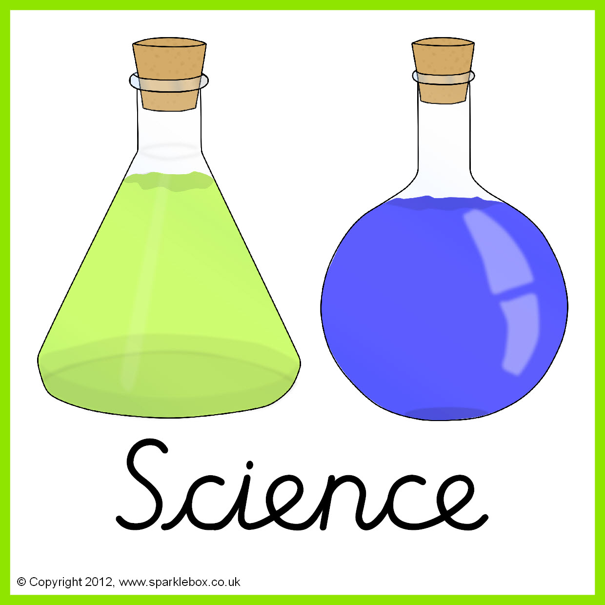



**Topics**

**Spring 1** - Strike a Pose.

**Spring 2** - Steam Punk Hats.

**Topic**

Island life.







**Topics**

**Spring 1** - Numbers to 25- How old are you?

**Spring 2** – Spanish instrument/music.

Months of the year.

**Topic**

Egypt- how people lived



**Topics**

**Spring 1** – Football.

**Spring 2** – Handball.

**Topics**

**Spring 1** – Judaism and Buddhism.

**Spring 2** – Easter story. Heroes and villains in the community.

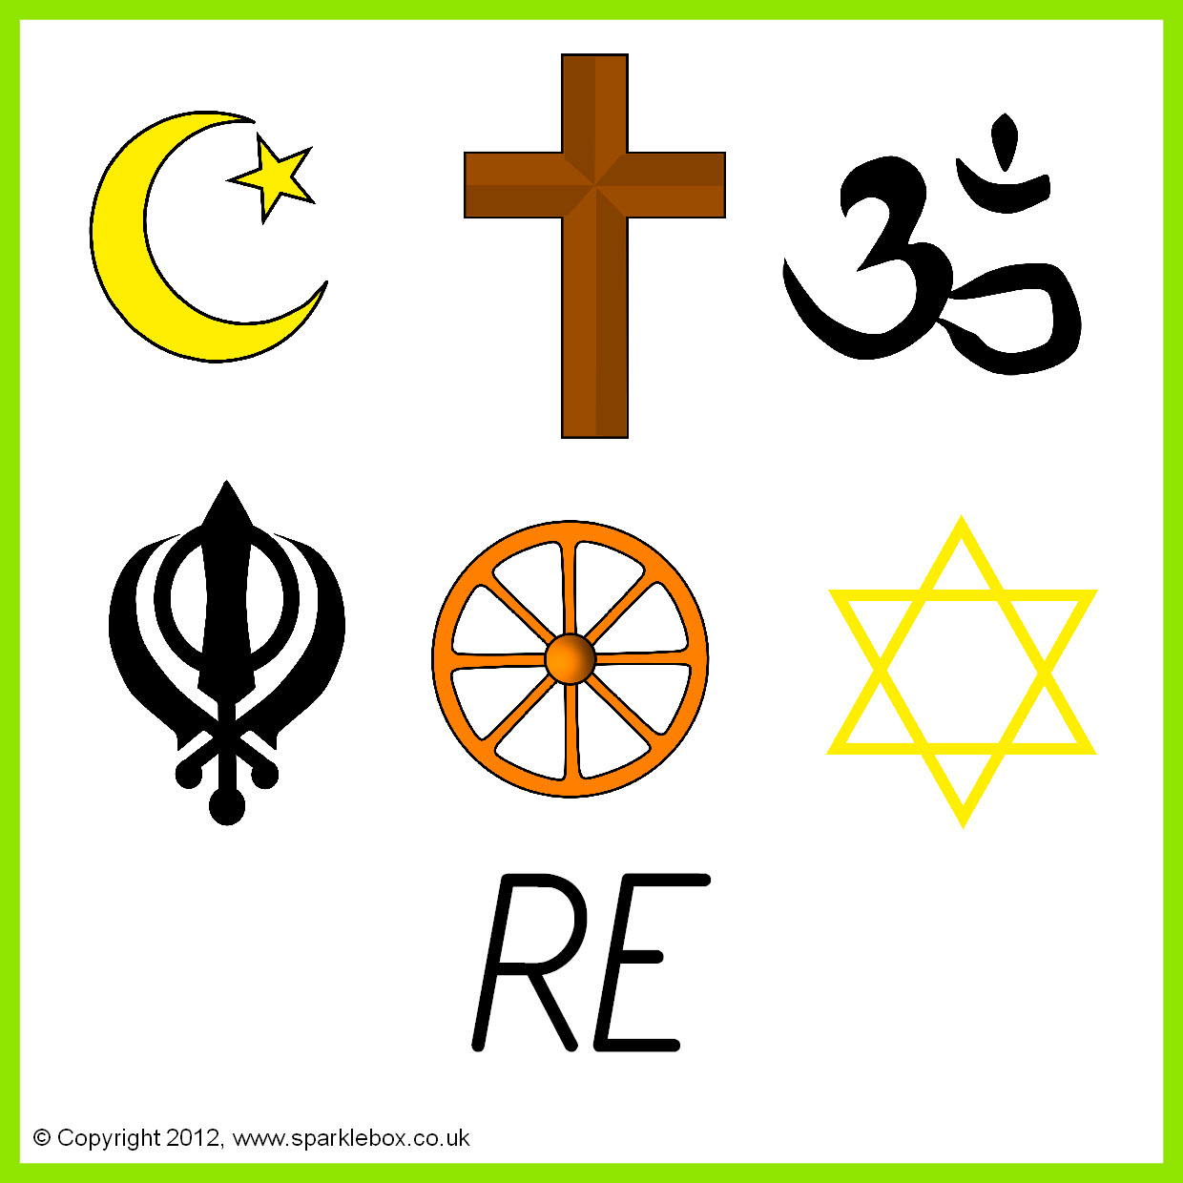



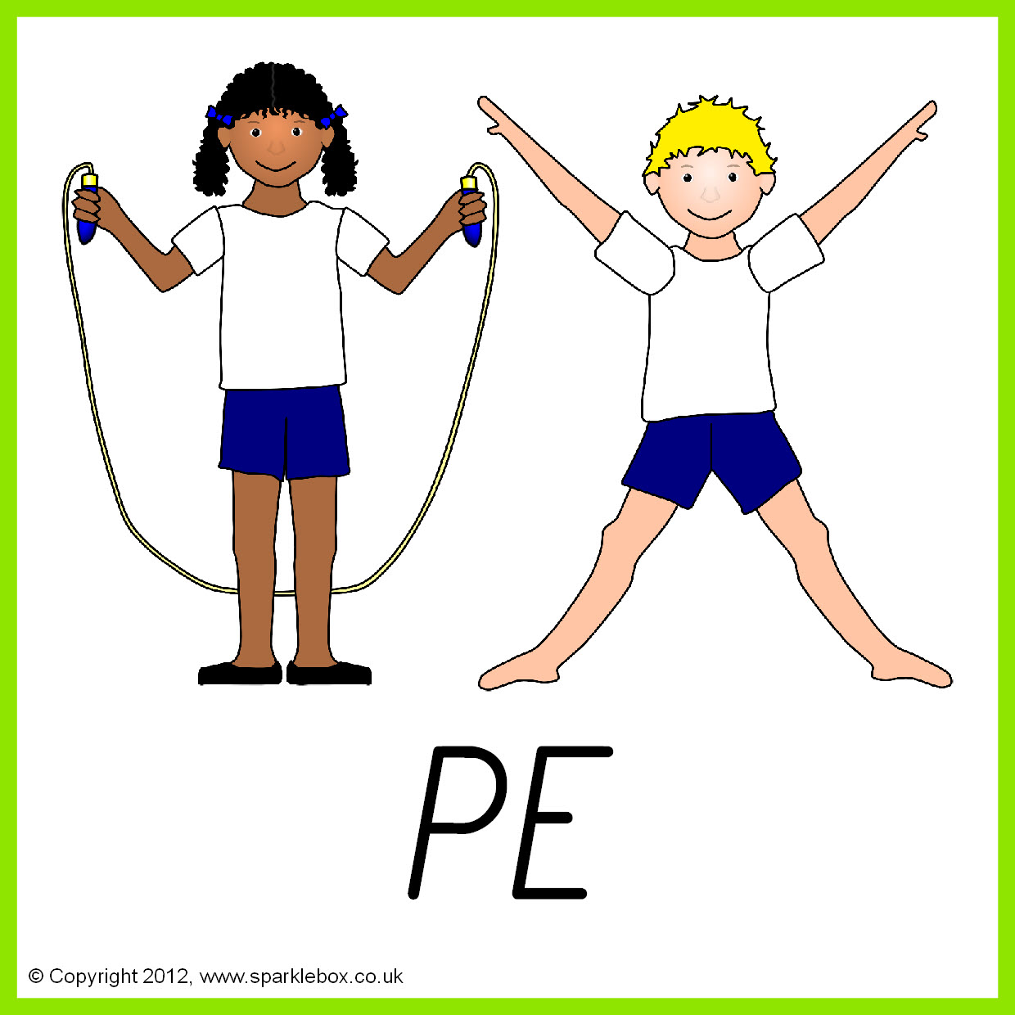

**Topics**

**Spring 1** – How electrical appliances work. How things work in the living room.

**Spring 2** – Meals in a hurry:

Quick/Convenience Meals.

**Topics**

**Spring 1** – Relationships with others.

**Spring 2** – Bullying- what is it?

.

