  Specialist School for    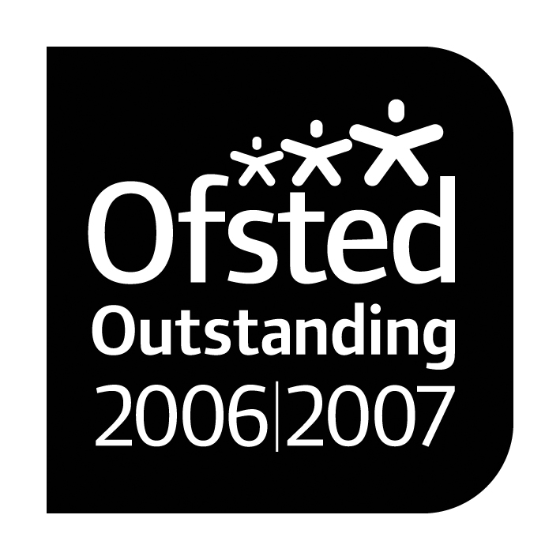      Cognition and Learning |  |   Paul King  Headteacher  Joanne Mullineux  Deputy Headteacher

13th February 2017

Dear Parents/Carers
Subject: School funding cuts
I am writing in the hope of gaining your support for our primary and secondary schools in relation to planned funding cuts across schools in Warrington. Parents and carers of young people across all of the schools in the borough will be receiving a similar letter.
You may be aware from the local or national news that the government is planning to introduce a new ‘National Funding Formula’ for all schools in England from April 2018 onwards.
In 2015 the government recognised that a ‘postcode lottery’ exists across the country when it comes to school funding and promised to introduce a fairer and less complex funding system for schools. We welcomed this and, as an area that receives a lot less than the national average, fully expected to see our budgets increase under the new system.
However, the proposed new formula has now been published and if it were to go ahead, far from making our funding fairer, it would make us one of the very worst funded areas for education nationally, placing us 141st in the country out of 150. Under the new formula, schools in the best funded authority in England will receive an average of £6,775 per child, while those in Warrington would receive £4,306 – a difference of £2,469 per child. Even compared to the national average, Warrington schools will still receive £439 less per pupil. Quite simply, the government have not ended the postcode lottery and Warrington schools will continue to suffer as a result.
If these proposals go ahead it means that across Warrington schools will have a total of almost a quarter of a million pounds per year wiped off their budgets on top of the very substantial cuts that nearly all schools have had to make over the past few years. Whilst some Warrington schools will see an increase in funding, the great majority will not – and even those who are set to benefit will be significantly worse off than similar schools in other areas of the country.
Unless the government can be persuaded to make changes, all Warrington schools will have some unpalatable choices to make over the next few years. Given that the greater part of school budgets relate to staffing costs, ultimately these cuts are likely to have a direct impact on the support that children across the borough receive – for example, in rising class sizes and a narrower curriculum.
While we agree with the government that a new formula is needed and few would argue with the desire to ensure that this helps schools in the most challenging areas to better meet the needs of disadvantaged children, the changes that the government are proposing do not address the fundamental issues in the current system. The top 16 best funded authorities remain at the top and the existing postcode lottery remains. Nothing has been done to ensure that schools in the worst-funded authorities – such as Warrington - are being adequately protected.
We passionately believe that every child, wherever they live, should have a right to the same opportunities for teaching, learning, care and support. The proposed formula does not deliver this and we hope to enlist your support in persuading the government to change it.
The government’s formal consultation runs until 22nd March 2017. You can find out more about it and see some of the questions other parents have been asking on the council’s website – www.warrington.gov.uk/schoolcuts
You may also wish to contact your local MP to seek their support. The contact details for Warrington MPs are below:
Helen Jones MP - Warrington North
Tel: 01925 232480
Email: jonesh@parliament.uk

David Mowat MP - Warrington South
Tel: 01925 231267
Email: david.mowat.mp@parliament.uk

If you have any questions about the proposed funding formula and the impact on our school, or would like to support the school in raising awareness of this critical issue, please let me know.
Yours faithfully
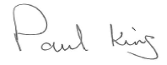
Paul King
Headteacher

