Spring/Summer 2022-2023 MENU – WEEK 2
OPTION | MONDAY |  | TUESDAY |  |  | WEDNESDAY |  |  | THURSDAY |  |  | FRIDAY
1 | Margarita Pizza served with baked jacket wedges & sweetcorn |  | Chilli beef served with 50/50 rice | 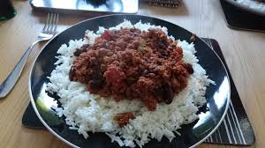 |  | Spaghetti Bolognese served with mixed vegetables | 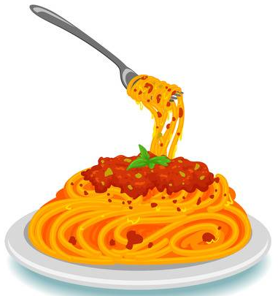 |  | Chicken curry & rice |  |  | Oven baked battered salmon served chips & peas or beans
2 |  |  | Hot ham & cheese panini, served with salad & coleslaw | 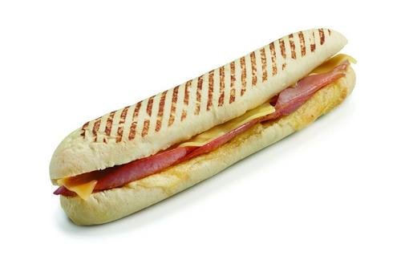 |  | Spicy Quorn served with savoury rice & mixed vegetables |  |  |  |  |  | Chicken goujons served with chips & peas or beans
JP | Jacket Potato | 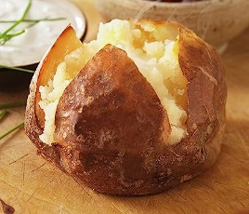 | Jacket Potato | 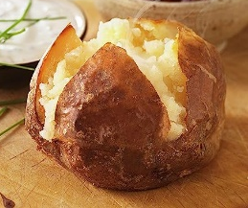 |  | Jacket Potato | 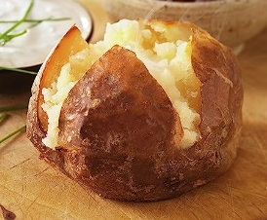 |  | Jacket Potato | 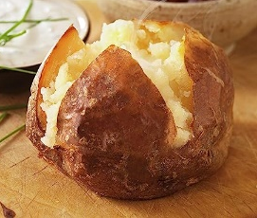 |  | Jacket Potato | 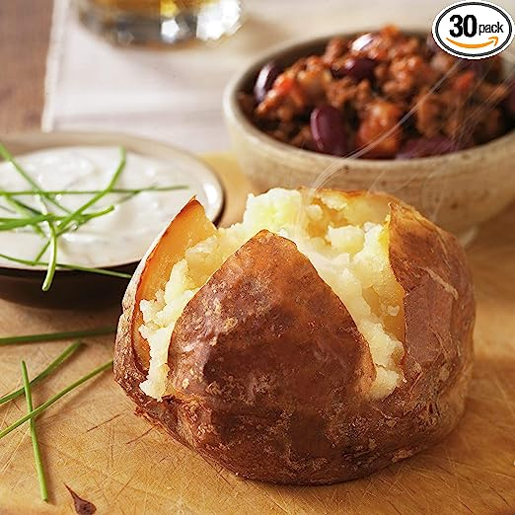
DESSERTS
 | Fresh fruit salad or yoghurt |  | Raspberry ripple ice cream roll |  | Jelly and fruit |  |  | Cook’s choice homemade carrot cake or banana and oat cake |  |  | Homemade cook’s choice biscuit
Available daily as an alternative:- Fruit yoghurt, a selection seasonal fresh fruit, soreen and cheese & biscuits
Unlimited fresh salad and unlimited wholemeal bread
LUNCH WILL BE SERVED WITH FRESH MILK OR WATER
Menu Cycle Week 2: 10th Apr, 1st May, 22nd May, 12th Jun, 3rd Jul, 24th Jul, 14th Aug, 4th Sep, 25th Sep, 16th Oct

