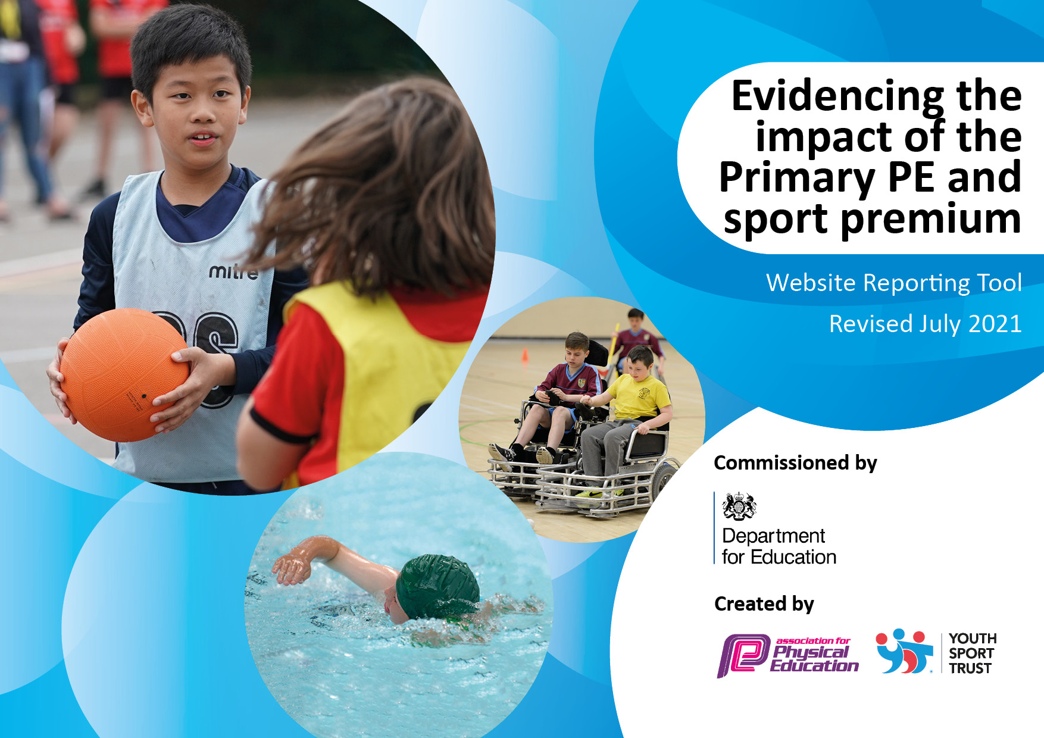
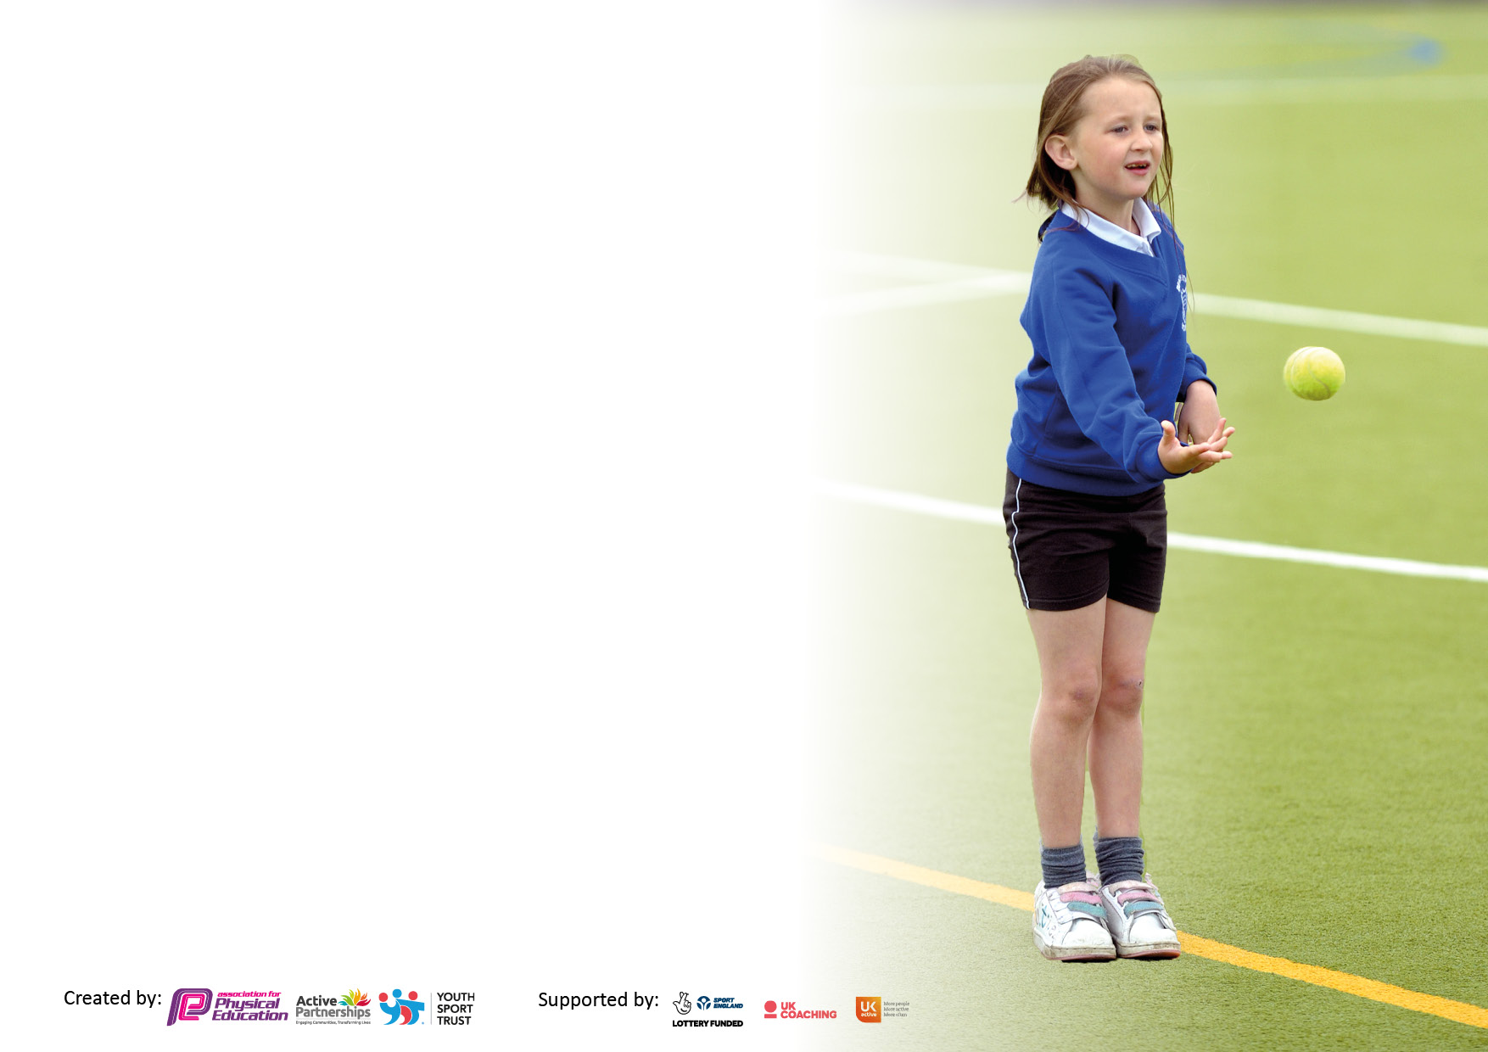

It is important that your grant is used effectively and based on school need. The Education Inspection Framework makes clear there will be a focus on ‘whether leaders and those responsible for governors all understand their respective roles and perform these in a way that enhances the effectiveness of the school’.

Under the Quality of Education Ofsted inspectors consider:
Intent - Curriculum design, coverage and appropriateness
Implementation - Curriculum delivery, Teaching (pedagogy) and Assessment
Impact - Attainment and progress

To assist schools with common transferable language this template has been developed to utilise the same three headings which should make your plans easily transferable between working documents.

Schools must use the funding to make additional and sustainable improvements to the quality of Physical Education, School Sport and Physical Activity (PESSPA) they offer. This means that you should use the Primary PE and sport premium to:

- Develop or add to the PESSPA activities that your school already offer
- Build capacity and capability within the school to ensure that improvements made now will benefit pupils joining the school in future years
- The Primary PE and sport premium should not be used to fund capital spend projects; the school’s budget should fund these.

Please visit gov.uk for therevisedDfEguidanceincludingthe5keyindicatorsacrosswhichschoolsshoulddemonstrate animprovement. Thisdocumentwillhelpyoutoreviewyourprovisionandtoreportyourspend.DfEencouragesschools to use this template as an effective way of meeting the reporting requirements of the Primary PE and sport premium.

We recommend you start by reflecting on the impact of current provision and reviewing the previous spend.

Schools are required to publish details of how they spend this funding, including any under-spend from 2019/2020, as well as on the impact it has on pupils’ PE and sport participation and attainment. All funding must be spent by 31st July 2022.

We recommend regularly updating the table and publishing it on your website throughout the year. This evidences your ongoing self-evaluation of how you are using the funding to secure maximum, sustainable impact. Final copy must be posted on your website by the end of the academic year and no later than the 31st July 2021. To see an example of how to complete the table please click HERE.

Details with regard to funding
Please complete the table below.

Total amount carried over from 2019/20 | £0
Total amount allocated for 2020/21 | £15,219
How much (if any) do you intend to carry over from this total fund into 2021/22? | £15,219
Total amount allocated for 2021/22 | £16,500
Total amount of funding for 2021/22. To be spent and reported on by 31st July 2022. | £31,719 (Planned spend of £24,735)
Swimming Data
Please report on your Swimming Data below.

Meeting national curriculum requirements for swimming and water safety.

N.B. Complete this section to your best ability. For example you might have practised safe self-rescue techniques on dry land which you can then transfer to the pool when school swimming restarts.
Due to exceptional circumstances priority should be given to ensuring that pupils can perform safe self-rescue even if they do not fully meet the first two requirements of the NC programme of study
What percentage of your current Year 6 cohort swim competently, confidently and proficiently over a distance of at least 25 metres?  N.B. Even though your pupils may swim in another year please report on their attainment on leaving primary school at the end of the summer term 2020.  Please see note above | No Data due to Covid restrictions
What percentage of your current Year 6 cohort use a range of strokes effectively [for example, front crawl, backstroke and breaststroke]?  Please see note above | No Data due to Covid restrictions
What percentage of your current Year 6 cohort perform safe self-rescue in different water-based situations? | No Data due to Covid restrictions
Schools can choose to use the Primary PE and sport premium to provide additional provision for swimming but this must be for activity over and above the national curriculum requirements. Have you used it in this way? | Yes/No

Action Plan and Budget Tracking
Capture your intended annual spend against the 5 key indicators. Clarify the success criteria and evidence of impact that you intend to measure to evaluate for pupils today and for the future.

Academic Year: 2020/21 | Total fund allocated: | Date Updated:
Key indicator 1: The engagement of all pupils in regular physical activity – Chief Medical Officers guidelines recommend that primary school pupils undertake at least 30 minutes of physical activity a day in school |  |  |  | Percentage of total allocation:
 |  |  |  | 12%
Intent | Implementation |  | Impact
Your school focus should be clear what you want the pupils to know and be able to do and about  what they need to learn and to  consolidate through practice: | Make sure your actions to achieve are linked to your intentions: | Funding allocated: | Evidence of impact: what do pupils now know and what can they now do? What has changed?: | Sustainability and suggested next steps:
Our focus is to enable all pupils to become more physically active at play times. By becoming more physically active, we strive to develop confidence and independence in our pupils. This increase in the opportunity to be physically active can nurture and develop positive attitudes towards sport and physical activity using structured and unstructured play, modelled and supported by trained staff.  We want our pupils to have the opportunity to experience a broad range of sports and physical activities. This can enable pupils to develop, or enhance, a passion for sport and/or find an activity that they wish to pursue outside of school. This would develop the engagement of our pupils in regular physical activity. | The development of playground areas, through a variety of engaging playground markings, provides more of an opportunity for our pupils to engage in meaningful physical activity at play times. This, supported by a replenishment and expansion of equipment, contributes to the development of the sport, PE and physical activity profile across the school and the development of the physical and emotional confidence of our pupils in relation to PESSPA.  The upkeep and enhancement of the ‘track’ will support the pupils’ physical activity levels both at play times and throughout the day, as classes are encouraged to access the ‘track’ for regular exercise. | £3000 | We expect to observe an increase in pupil physical activity at play times. Our pupils will demonstrate an increased enthusiasm for physical activity and demonstrate a development of skills over an appropriate length of time. Pupils will be more confident with their own abilities, and with the increase in physical demand within the school day. Pupil fitness should be improved, alongside the development of gross motor skills and fundamental key skills. | To ensure the playground markings have a sustainable impact, the introduction and development of ‘play leaders’ will enable there to be structured play (as well as independent play) that will also allow a variety of pupils to develop leadership skills.
Key indicator 2: The profile of PESSPA being raised across the school as a tool for whole school improvement |  |  |  | Percentage of total allocation:
 |  |  |  | 4%
Intent | Implementation |  | Impact
Your school focus should be clear what you want the pupils to know and be able to do and about  what they need to learn and to  consolidate through practice: | Make sure your actions to achieve are linked to your intentions: | Funding allocated: | Evidence of impact: what do pupils now know and what can they now do? What has changed?: | Sustainability and suggested next steps:
Our focus is to further develop the opportunities for our pupils to be physically active and to be involved in a variety of sports and activities. This is further outlined in key indicators 1 and 4. The development of opportunities to be physically active and experience a broad range of activities can raise the profile of PE and sport across the whole school. By broadening the sports and activities delivered to pupils in PE, we want our pupils to foster and develop a love of PE, sport and physical activity. We want them to experience a variety of sports and activities that may lead them to further develop skills and/or seek to take up sports and activities out of school.  We want our pupils to have opportunities to take on leadership roles in sport to enhance the development of skills and confidence. The use of sport leadership roles can influence and encourage other pupils to aspire to take on leadership roles or to become more physically active. | The development of play time activities through a variety of engaging playground markings and the enhancement of sport equipment will make PESSPA more visible within the school and encourage physical activity to be taking place throughout the school day by pupils across all key stages. This will be further supported through the development of play leaders, who will offer positive role models to peers and younger pupils.  The broadening of the sports and activities delivered to pupils can further raise the PESSPA profile across the whole school by engaging a greater number of pupils in sport and physical activity. The use of qualified sports coaches, such as Judo and the Wolves, to deliver aspects of the PE curriculum will provide pupils with high-quality coaching and an exposure to sports and physical activities that may not otherwise have been offered. | £1000 | The engagement of pupils in sport and physical activity will be increased.  The number of pupils taking on leadership roles will increase, and their skills as leaders will develop throughout the year and beyond.  The engagement of pupils in sport and physical activity outside of school will be increased. | By building strong foundations for PESSPA in school (through a broad curriculum, engaging play times and leadership opportunities), the development of the PESSPA profile will be sustainable as both staff and pupils will be engaged in sport and physical activity throughout the day, week and year.  The development of whole school sporting activities will further raise the PESSPA profile across the school. Events such as ‘sports week’ (to replace ‘sports day’), intra competitions and sponsored events for charity, will engage and encourage our pupils to be excited about sport and physical activity and want to participate.

Key indicator 3: Increased confidence, knowledge and skills of all staff in teaching PE and sport |  |  |  | Percentage of total allocation:
 |  |  |  | 12%
Intent | Implementation |  | Impact
Your school focus should be clear | Make sure your actions to | Funding | Evidence of impact: what do | Sustainability and suggested
what you want the pupils to know | achieve are linked to your | allocated: | pupils now know and what | next steps:
and be able to do and about | intentions: |  | can they now do? What has
what they need to learn and to |  |  | changed?:
consolidate through practice:
Our focus is to develop the knowledge and confidence of staff when planning and delivering PE and sport. This development will further support the provision of high-quality PE across the school.  Through the delivery of high-quality PE and sport, our pupils can develop their skills and confidence and are more likely to make expected progress in PE. Furthermore, the development of staff knowledge and confidence can further support the preparation of our pupils for inter and intra sport competitions. This will provide more opportunity for our pupils to access and progress on the talent pathways. | The implementation of the RealPE programme into our school PE and sport curriculum provides staff with training opportunities to use the programme effectively, and specifically for our pupils as the training is tailored to our specific staff needs. The RealPE digital platform offers staff virtual support and resources that can be accessed and adapted to suit specific needs of individual classes and pupils.  By using the RealPE programme, staff are sufficiently supported and have resources readily available to further enhance their planning and delivery of PE lessons. | £3000 | The confidence of staff will increase, and the delivery of high-quality PE will be enhanced. The engagement of pupils in PE and physical activity will reflect the delivery of high-quality PE lessons. This will be supported by the resources provided by the RealPE programme, which offer visuals and interactive materials for pupils.  Pupils will develop their physical skills and their knowledge and understanding of PE and physical activity through the high-quality teaching and the resources used during lessons. | The training of staff offers sustainability as the developed skills and knowledge can be used year-on-year.  Experienced staff, and the PE subject leader, can support new staff, further supported by the RealPE representatives.
Key indicator 4: Broader experience of a range of sports and activities offered to all pupils |  |  |  | Percentage of total allocation:
 |  |  |  | 61%
Intent | Implementation |  | Impact
Your school focus should be clear | Make sure your actions to | Funding | Evidence of impact: what do | Sustainability and suggested
what you want the pupils to know | achieve are linked to your | allocated: | pupils now know and what | next steps:
and be able to do and about | intentions: |  | can they now do? What has
what they need to learn and to |  |  | changed?:
consolidate through practice:
Our focus is to deliver a broad and balanced curriculum that is challenging and engaging for our pupils. We want our pupils to experience a wide range of sports and physical activities at each key stage to develop their engagement in, and passion for, sport and physical activity.  Moreover, we want our pupils to have the opportunity to pursue any physical activities outside of school. The provision of a broad range of sports and activities will give our pupils a greater opportunity to find an activity that they wish to pursue. The links made with any external coaches or organisations will provide contacts for our pupils to engage with to pursue activities. | The development of Outdoor Adventurous Activity (OAA) across the school will provide pupils the opportunity to gain more valuable experiences in this area. A bespoke orienteering course on the school grounds will provide an opportunity for pupils to develop physical and academic skills through activities that are tailored to individual and class needs.  The investment into sports equipment can provide a wider range of sports and physical activities that can be delivered as part of the curriculum. Equipment such as a table tennis table could provide opportunities for both table tennis and table cricket to be delivered as part of PE and as extra-curricular clubs. Equipment such as this will also support the preparation for competitions, potentially raising pupil success and therefore opportunities to compete in additional competitions.  The use of sports coaches to support the curriculum delivery will provide pupils the opportunity to experience sports and activities that may be beyond the skills of teachers and school staff, such as martial arts. Moreover, the use of these coaches will provide useful contacts that may enable our pupils to engage in activities outside of school. | £15,000 | Pupil independence and confidence will be developed, particularly amongst our Key Stage three and four pupils, by the introduction of a bespoke orienteering course and the opportunity to experience more OAA activities.  The skill level amongst pupils across a variety of sports and physical activities will be increased. Additionally, the engagement levels and excitement of pupils will be increased as they get to experience sports and physical activities that they may not have tried before. The more sports and physical activities on offer, the more chance we have at engaging most pupils in PE and physical activity. | The introduction and maintenance of a bespoke orienteering course will provide opportunities for pupils both now and in the future. The training of staff to deliver orienteering, and OAA, effectively will provide more opportunities for pupils to develop their confidence and skills.  For the provision of a broad range of sports and activities to be delivered, the curriculum needs to be regularly reviewed to ensure it is suitable for the pupils that are accessing it. Adaptions should be made to ensure the provision of a broad range of suitable activities to provide the best PE and sport for our pupils.

Key indicator 5: Increased participation in competitive sport |  |  |  | Percentage of total allocation:
 |  |  |  | 11%
Intent | Implementation |  | Impact
Your school focus should be clear | Make sure your actions to | Funding | Evidence of impact: what do | Sustainability and suggested
what you want the pupils to know | achieve are linked to your | allocated: | pupils now know and what | next steps:
and be able to do and about | intentions: |  | can they now do? What has
what they need to learn and to |  |  | changed?:
consolidate through practice:
Our focus is to provide all pupils with the opportunity to experience competitive sport, through both inter and intra sport competition. The participation in competitive sport enables our pupils to apply, and further develop, their skills and to build confidence in their ability.  Inter sport competitions and those organised by external providers also provide our pupils with opportunities to develop social and independence skills in a variety of environments and contexts. | Through the implementation of the RealPE programme, staff knowledge and confidence in delivering high-quality PE and sport will continue to develop. This, as explored in key indicator 3, will enhance pupil skill development and could open additional opportunities for competition at higher levels.  The continuation of the Warrington PE and School Sport subscription provides a variety of competitions for our pupils to access. | £2735 | The number of pupils participating in sporting competitions will increase, both inter and intra competitions. There will be an increased sense of achievement amongst pupils and pride in whole school and individual achievements.  The number of external competitions that we attend as a school will increase and the opportunity to attend higher level school games may increase as a consequence (qualifying may be required)  The number of intra sports competitions held in school will increase, with a variety of sports and physical activities being experienced. | The training of staff offers sustainability as the developed skills and knowledge can be used year-on-year. Experienced staff can support new staff, supported by further training from the RealPE representatives.  The involvement with Warrington PE and School Sport provides networking opportunities for further involvement in sport competitions organised by us, such as competitive sport between schools.

