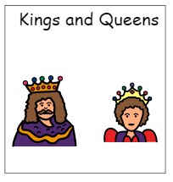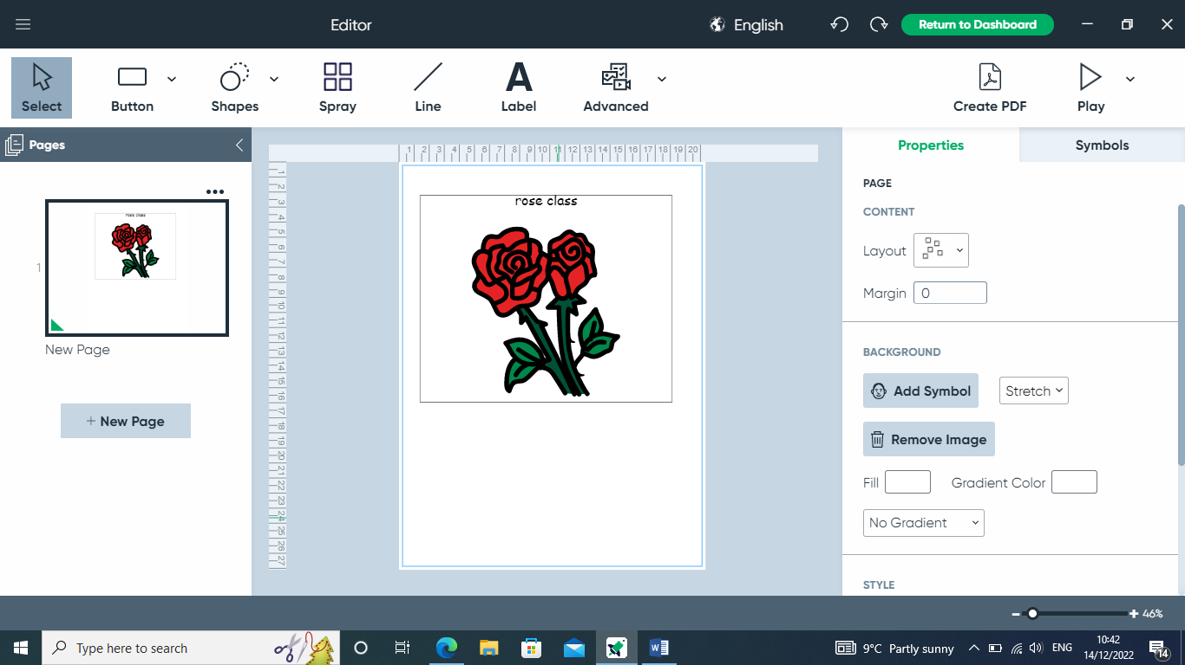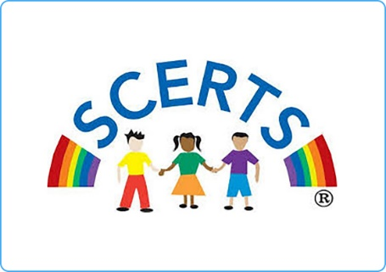

**Topics**

Making groups

Collecting information

Pictograms

3D shapes

Adding and subtracting

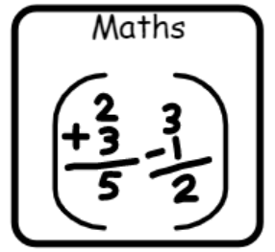

**Topics**

Fairy tales

Mythical places

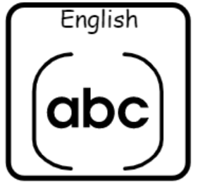

**Topics**

Data counting

Multimedia - photographs

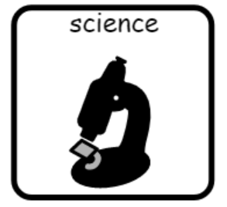

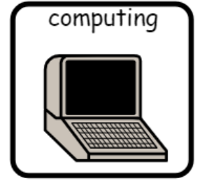

**Topics**

Forces

Testing materials

Science day – Stars and space

**Topic**

Portraits

**Topic**

England and Ireland

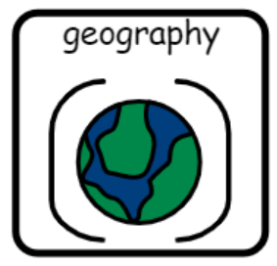

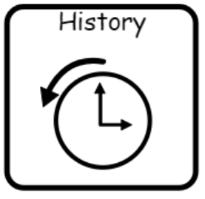

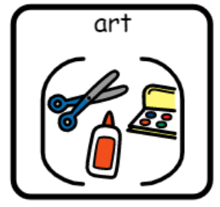

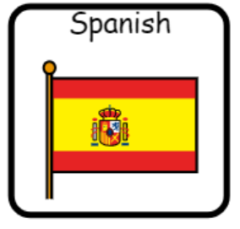

**Topics** –

Spanish dancing and instruments

The Spanish flag

**Topic**

Where do kings and queens live?

**Topics**

Hinduism

Jesus as a leader

**Topics**

**Health and fitness**

**Athletics**

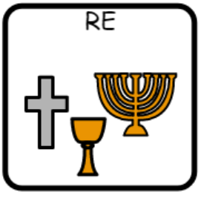

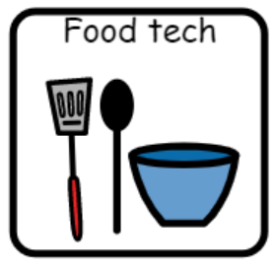

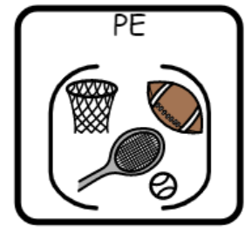

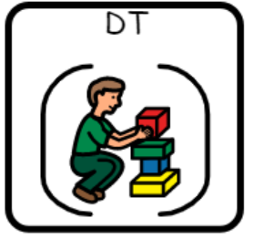

**Topic**

Cakes and treats – A royal afternoon tea

**Topic** –

Crowns