Fox Class Autumn Term 2022



Badger class staff.

Mr A. Sidhu

Mrs E. Burton

**Topics**

**Autumn 1 -**

Place Value and Number. Solve practical problems involving place value.

**Autumn 2 -** Add and subtract numbers using a formal written method and mental. Properties of 2D and 3D shapes, lines of symmetry.

**Topics**

**Autumn 1 –** Stories by Roald Dahl and the autobiography.

**Autumn 2 –** Explanations

**Ongoing** - Spelling and Phonics, Guided Reading, Guided Writing, Handwriting.

Speech and language work.

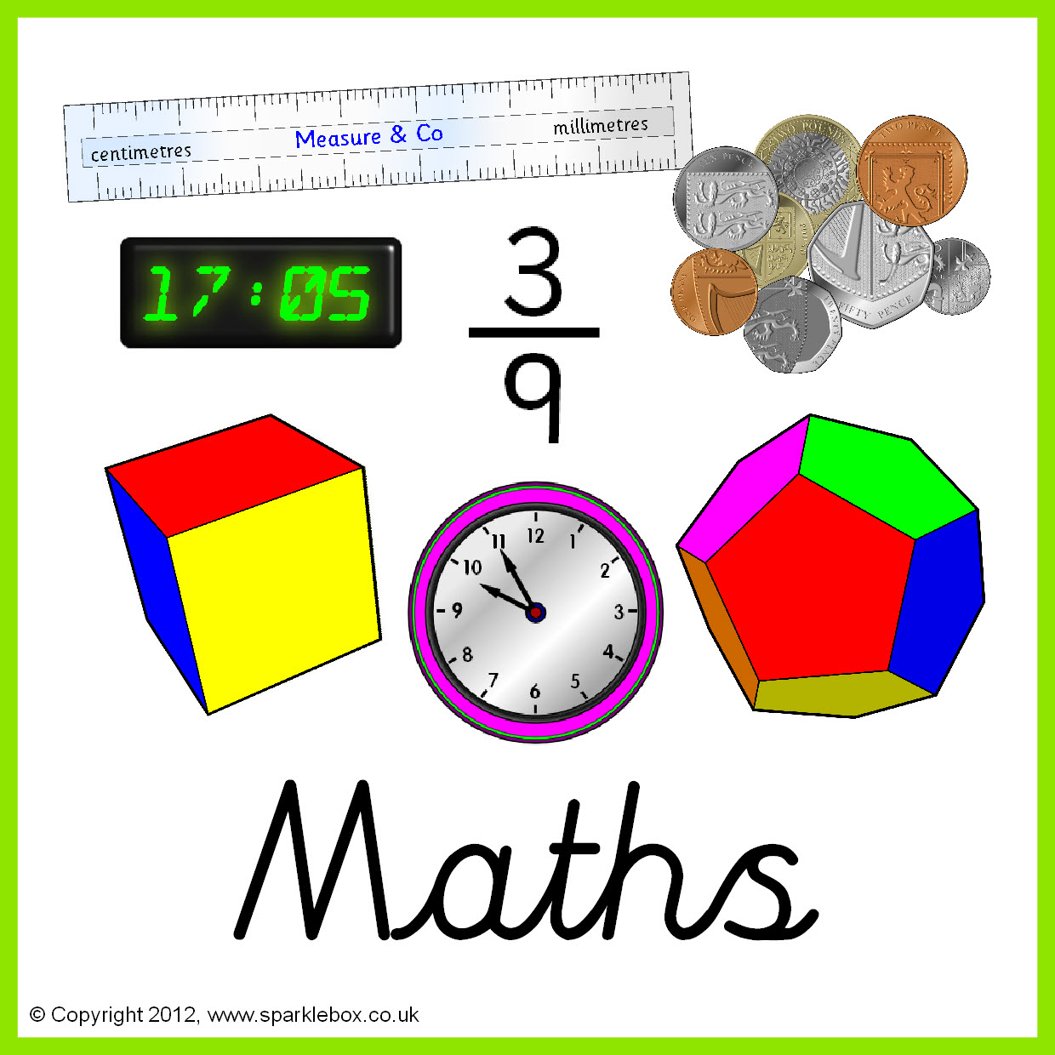



**Topics**

**Autumn 1** – Forces - Resistance, gravity and friction.

**Autumn 2** - Properties and changes of materials- Solids, liquids, gases.

Properties and changes of materials.

**Topics**

**Autumn 1** – Key Computer skills.

**Autumn 2** – E-Safety.





**Topics –**

**Autumn 1** - Introduction to formal elements of art.

**Autumn 2** – Spanish Tiles

**Topics** -

**Autumn 1 –** Alaska

**Autumn 2 -** Cuba







**Topics -**

**Autumn 1** – Numbers to 25. Spanish greetings.

**Autumn 2** – All about Spain.

**Topic** – **Autumn 1 –** The invasion of Roman Britain.

**Autumn 2** – The Egyptians



**Topics -**

**Autumn 1** – Football/Tag Rugby

**Autumn 2** – Gymnastics and Dance

**Topics**

**Autumn 1** – Various Religions- Where do we Belong?

**Autumn 2** – Christianity and Judaism.





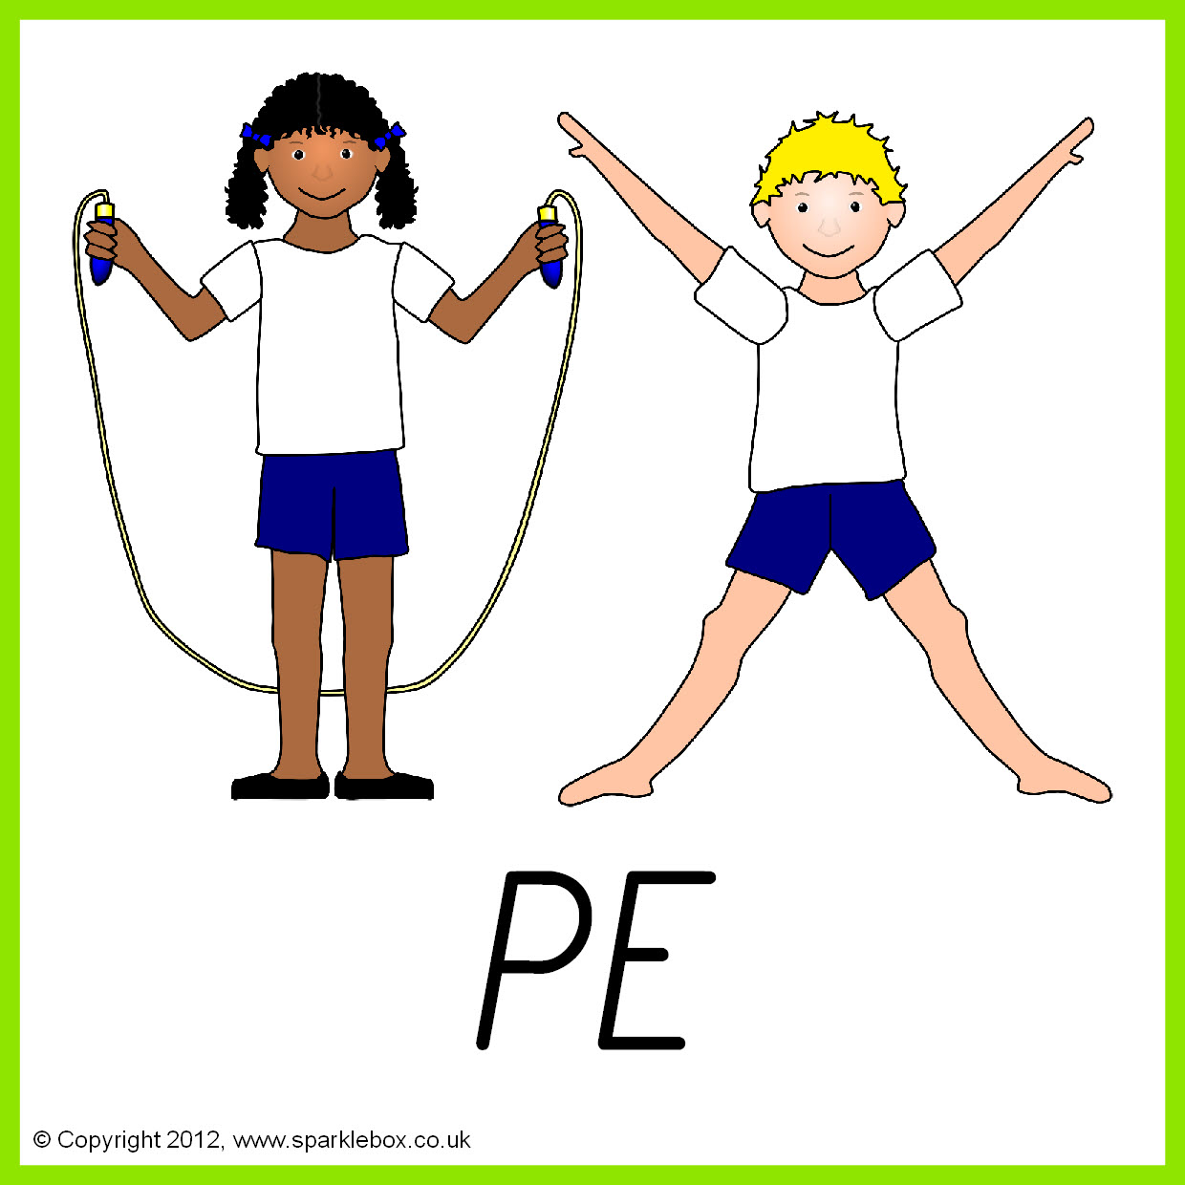

**Topics -**

**Autumn 1** – Inventions and inventors.

**Autumn 2** – Basic food hygiene.

**Topics**

**Autumn 1** – Talking about Emotions.

**Autumn 2** – Keeping Safe (First Aid, Road Safety etc.

.

