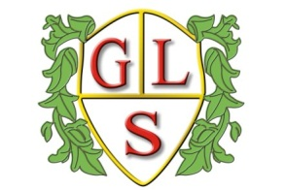
Class Poppy Topics

Autumn Term
Overview 2023-2024

Maths
Number
Place Value
2D Shape
Time
Money
Length
Data handling

English
Traditional Tales
Poems: Nonsense

Science
Describing materials and their properties
Why do animals live there?

Computing
What is a computer?
E-Safety

History
Volcanoes

Geography
Comparing Warrington and a Non-European City

RE
Hindu Dharma
Celebrations

Spanish
My Spanish Passport
Spanish Food/Spanish Christmas

Art
Indian Art and Craft

DT
Textiles: Fabric bunting

PSHE
Feeling safe including online
What is bullying?

PE
Wolves Foundation

