Glory for Green Lane!!
Green Lane returned as champions from the 2018 Wooden Spoon MLD competition, held at Blackburn RUFC.
Green Lane emerged as winners of their group having recorded 3 wins and a draw and went straight into the cup as one of three group winners.
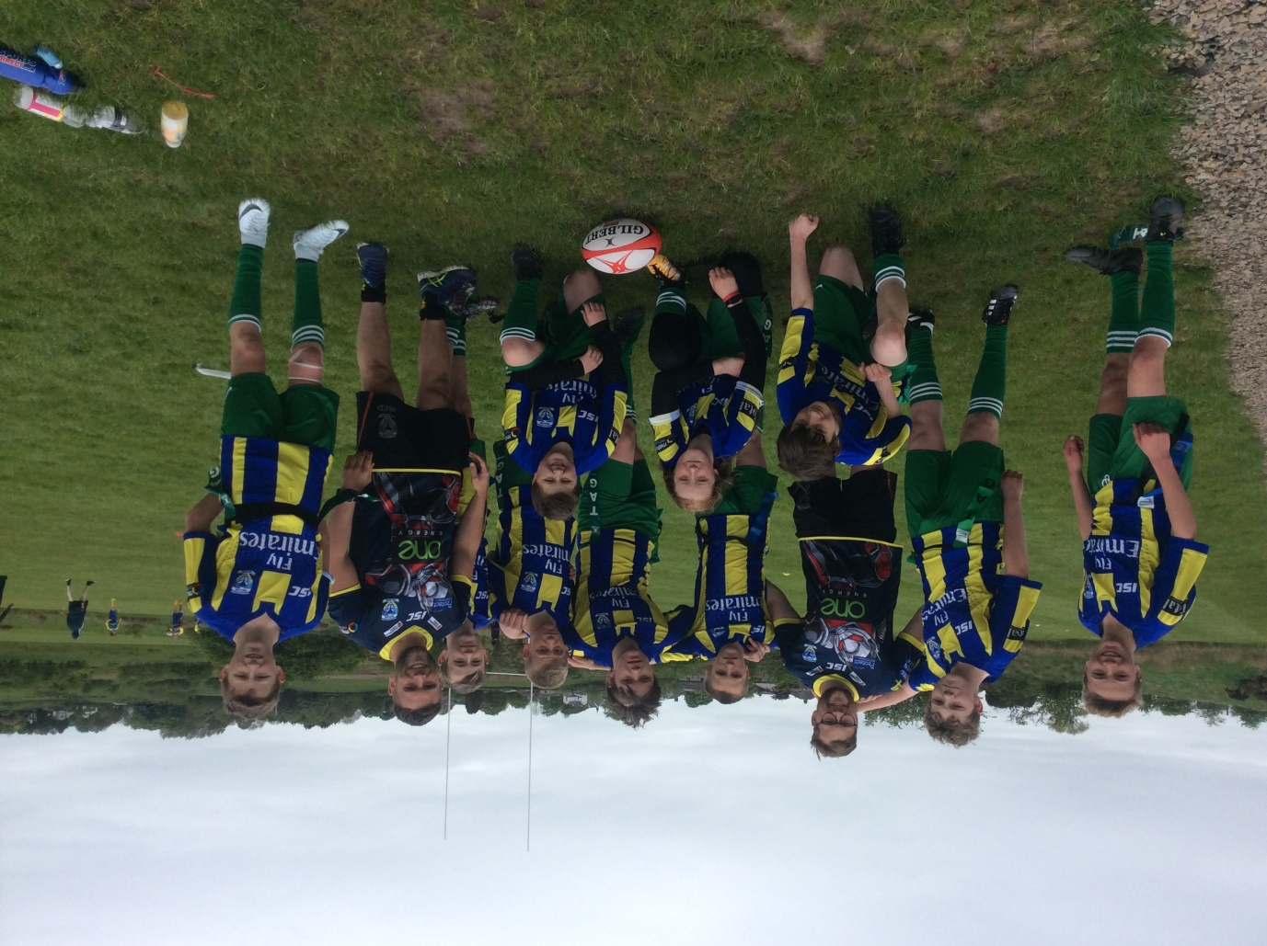
The Green Lane squad joined by Wil Maudsley and Craig Thomason of the Wolves Foundation.
The team have been taking part in training sessions with the help of the Wolves staff and it certainly seemed to have paid off during the early rounds of the competition.
The break for lunch came at an opportune time as Green Lane legs were beginning to look tired. Batteries were recharged and sore limbs rested, meaning that the team went into the knockout stages refreshed.
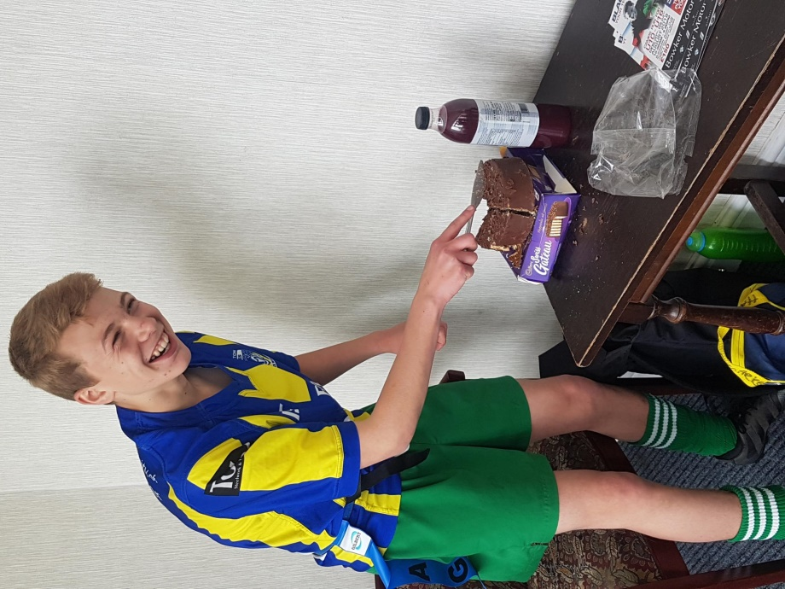
L. Groarke making an interesting case to become the Green Lane nutritionist……
Green Lane warmed up for the knockout stages with a swiftly arranged defensive session with Mr King and the two Wolves coaches. This had the desired effect of focusing minds and the team went into their next game full of confidence. A titanic battle ensued and Green Lane had to be at their very best to keep in touch with their opponents. A remarkable defensive effort in the closing minutes of the game saw Green Lane force an error and break away to score the winning try.
With one game remaining Green Lane knew that victory could secure them the trophy. To that end the team continued to exert their defensive strength which, allied to their ruthless attack, proved too much for their opponents to manage. Another hard fought victory meant that Green Lane had done it and were champions!
The whole squad did themselves and the school proud, every player making countless telling contributions.
The squad was:
R. Mahoney c, L. Groarke, N. Hewitt, L. Davies, D. Smythe, C. Cartledge, O. Walters, C. Gough, C. Mahoney, L. Beaton.

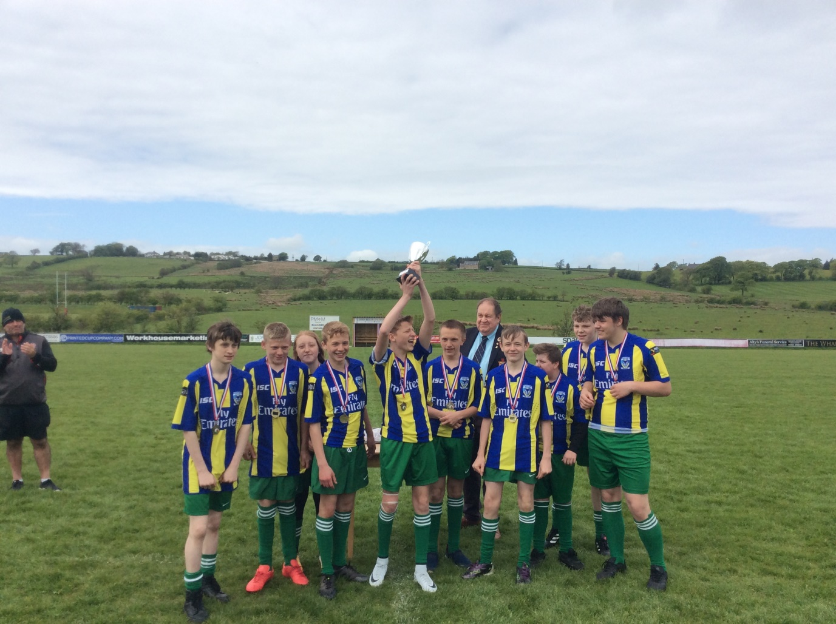
The team receive the trophy from the President of Lancashire RFU.
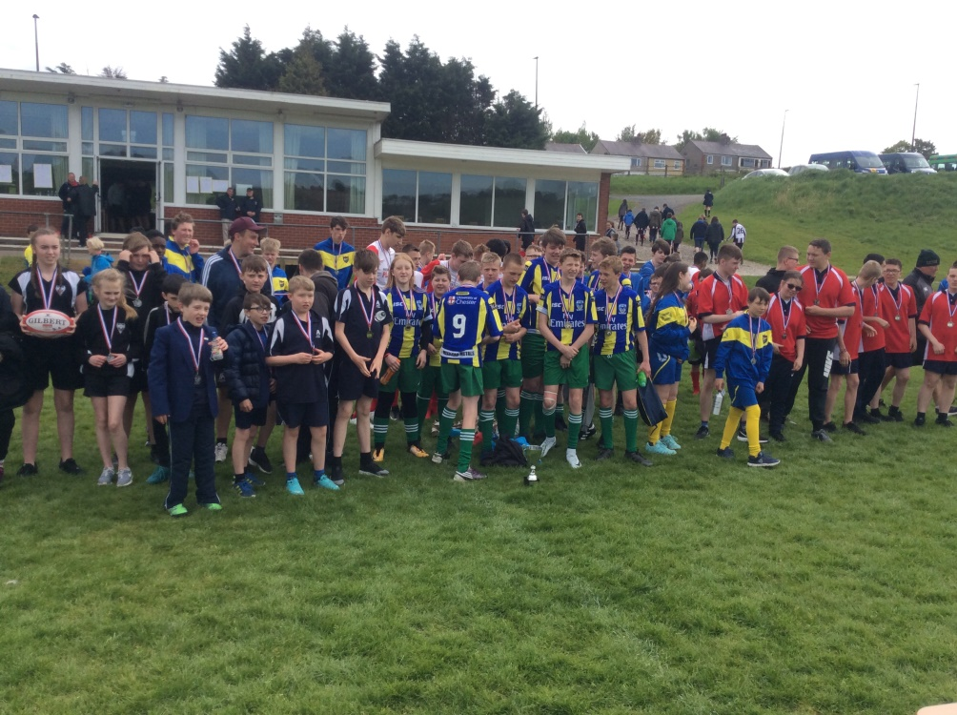
Sharing the celebrations with some of our opponents.

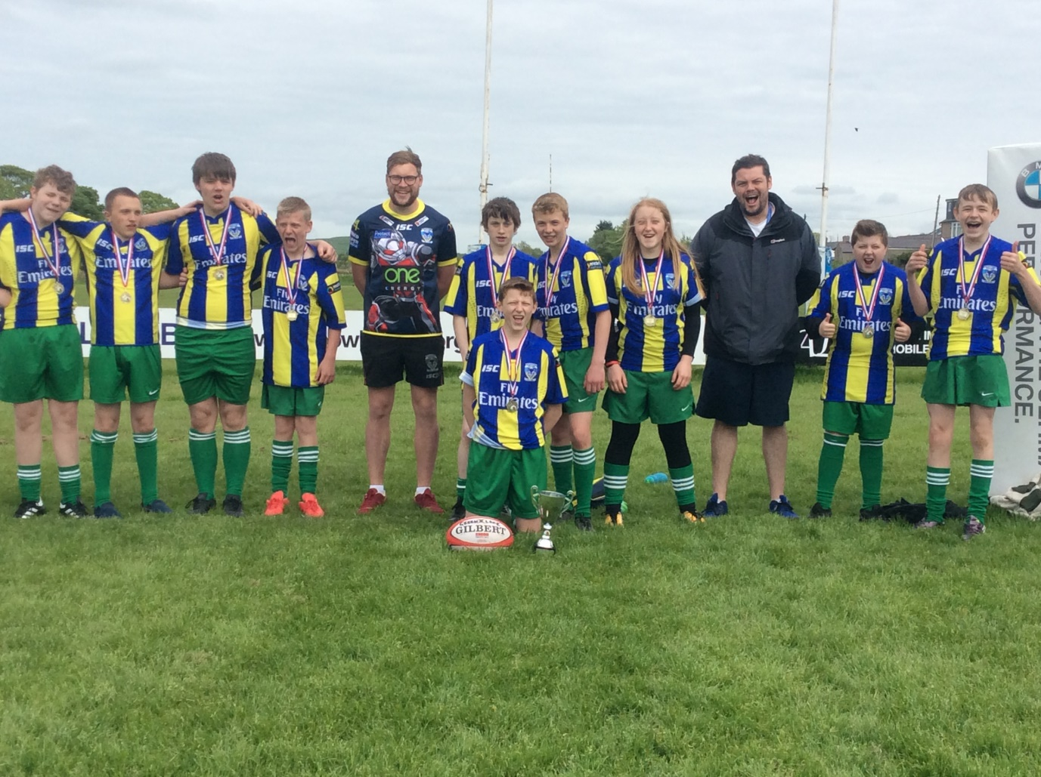
Celebrating with Wil and Mr King.
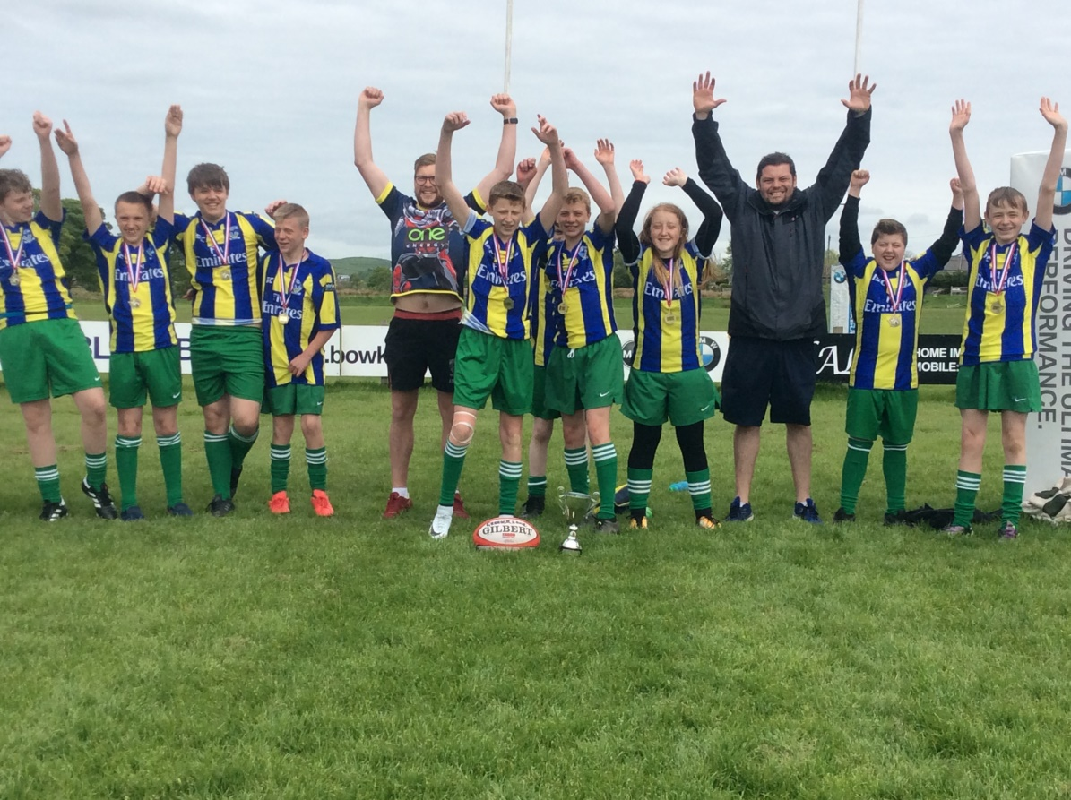
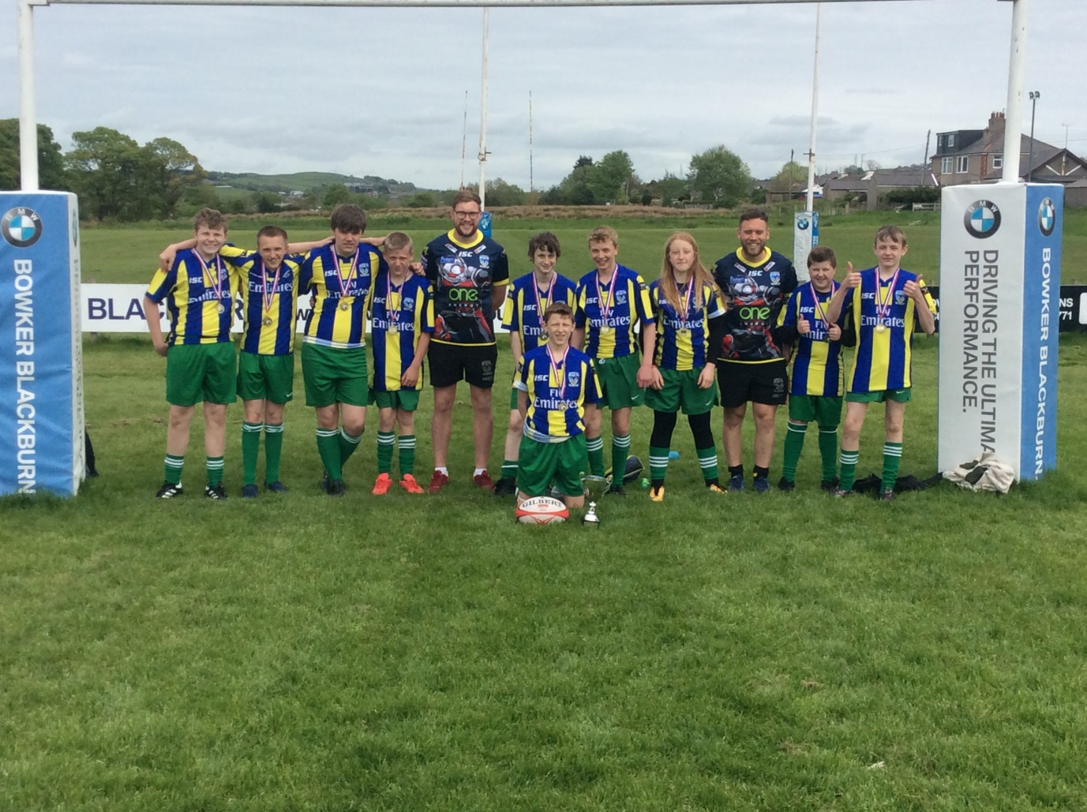
A massive thank you to Wil and Craig from the Wolves foundation. Wil has run a number of sessions for the team which have certainly had an impact on performance! Craig has supported the team with his time for a number of years and secured them the opportunity of wearing the Warrington kit today. The Wolves run lots of disability sport in the Warrington area and are great friends and supporters of our school. If you are interested in getting your child involved in this fantastic organisation then please contact school for more information!

